|  |  |
| --- | --- |
| ­­­­ | **FPT ACADEMY INTERNATIONAL**  **FPT – APTECH COMPUTER EDUCATION** |

**Centre Name: ACE-HCMC-2-FPT.**

**Address: 590 Cach Mang Thang 8, District 3, Ho Chi Minh City, Viet Nam.**

**VEHICLE INSURANCE MANAGEMENT**

|  |  |  |
| --- | --- | --- |
| **Supervisor:** | Hoang Duc Quang | |
| **Semester:** | 3 | |
| **Batch No:** | T1.1810.E0 | |
| **Group No:** | 3 | |
| **Order:** | **Full name** | **Roll No.** |
| 1. | Nguyen Huu Tung | Student1151428 |
| 2. | Bui Nguyen Hai | Student 1159262 |
| 3. | Truong Hoang Huy | Student1141480 |
| 4. | Nguyen Minh Thu | Student1122727 |

Month 01 Year 2020

This is to certify that

Mr. **Nguyen Huu Tung**

Mr. **Bui Nguyen Hai**

Mr. **Truong Hoang Huy**

Ms. **Nguyen Minh Thu**

Has successfully Designed & Developed

**eProject: Vehicle Insurance Management**

Submitted by:

**Nguyen Huu Tung**

Date of Issue:

**27 – Feb – 2020**

Authorized Signature:

Table of Contents

PROBLEM DEFINITION 7

CUSTOMER REQUIREMENT SPECIFICATION 8

Customer 8

Employee 9

Hardware 9

Software 9

Expected release date 9

List of deliverables 10

PROJECT PLAN 11

E-R DIAGRAM 12

Database table design 12

Diagram 15

USE CASE 16

Static page 16

Customer 17

Admin 18

SEQUENCE DIAGRAM 19

Login 19

Customer 19

Admin 20

ALGORITHMS 21

Login 21

Customer 22

Admin 23

GUI STANDARDS DOCUMENT 24

INTERFACE DESIGN DOCUMENT 26

Home page 26

About Us 27

Types of Insurance 28

Testimonials 29

Site map 30

Contact Us 31

Customer – Login | Register | Forget Password 32

Login 32

Register 32

Forget Password 34

Customer – profile 35

Customer – Your vehicle 36

Create new vehicle 36

Create estimate 37

Create insurance 38

Create Billing policy 39

Customer – Billing 40

Billing policy details 41

Request a claim 41

Customer – Paid Status 42

Clam Details 43

Admin – Layout – Boxed 44

Admin – Layout – Fixed 44

Admin – Layout – Collapsed Sidebar 45

Admin – Dashboard 45

Admin – Admin List 47

Create new admin / staff 47

Edit admin account 48

Admin details 48

Admin – Customer List 49

Create new customer 50

Create new vehicle 50

Customer details 51

Admin – Vehicle – Vehicle List 51

Vehicle edits 52

Vehicle details 52

Admin – Vehicle – Vehicle Model 53

Create new model 53

Create vehicle version 54

Edit vehicle model 54

Admin – Vehicle – Vehicle Version 55

Create vehicle name 55

Edit vehicle version 56

Version Status 56

Admin – Vehicle – Vehicle Name 57

Edit vehicle name 57

Vehicle name details 58

Vehicle name Status 58

Admin – Insurance Type – Vehicle Warranty 59

Edit Vehicle warranty 59

Vehicle warranty status 59

Admin – Insurance Type – Vehicle Policy Type 60

Edit Vehicle policy type 61

Vehicle policy type details 61

Vehicle policy status 61

Admin – Insurance Type – Addition service (Add prove) 62

Edit customer add prove 63

Customer add prove details 63

Add prove status 63

Admin – Billing 64

Billing policy details 65

Admin – Claim – Process 65

Create claim payment 66

Insurance claim details 66

Admin – Claim – Success 66

Create new claim payment 67

Edit claim payment 68

Claim payment details 68

Admin – Expenses 68

Create new expenses 69

Edit expenses company 70

Admin – Report 71

Customers report 71

Claims report 73

Billings report 73

Expenses report 75

Policies lapsed report 75

TASK SHEET 77

UNIT TESTING CHECK LIST 83

# PROBLEM DEFINITION

The objective of the system is to provide the facilities to all the people concerned with Vehicle Insurance. From the management point of view, works can be done fast and more accurately as compared to the existing manual system. From the customer’s point of view, he can get immediate services without any kind of wasting of time whereas from the user’s point of view all kinds of transitions can be done in a very easy and efficient manner.

The system also provides many kinds of reports generation facilities. Our main objectives for developing this project are giving below.

**DATA SECURITY.**

**REDUCED PAPERWORK.**

**REDUCED MANPOWER.**

**INCREASED OPERATIONAL EFFICIENCY.**

**INCREASED ACCURACY AND RELIABILITY.**

**IMPROVE MORAL.**

**REDUCE OPRATIONAL TIME.**

This project aims to develop a complete fully functional independent system with the intention of improving the productivity of the operations of the company through speedy and accurate processing and efficient storage and retrieval of data.

The basic aim behind this project to provide a complete solution that manages the records of the vehicle insurance company.

# CUSTOMER REQUIREMENT SPECIFICATION

This project is aimed to develop “Online Insurance Portal”. It is a web-based application, which is developed mainly for the agents of the insurance company to take the policy for his clients electronically. By the request from his clients, he processes and maintains the policy details through the system.

Online Insurance Portal System is an integrated insurance system which links up all the channels within the insurance industry. It is a revolutionized insurance solution that can facilitate online processing and services to the insurance partners, agents, and customers through the Internet.

The site should have menu categorizing required functionalities

* **About us**
* **Types of insurance**
* **Testimonials**
* **Site map**
* **Contact us**

There should be 2 logins as mentioned below:

## Customer

User needs to register as a customer by providing the necessary information in the registration form and provide the username and password

Customers can log in with a unique username and password.

He can change the password.

Can purchase the policy online: For purchasing the policy online, he has to fill in the application form which would capture all the required information about the vehicle. On successful payment, a copy of the policy would be generated which customers can save for the records.

Initiate the claim by filling the claim form.

## Employee

Employee will be admin who can log in with admin username and password.

He can perform all the admin functions as maintaining the policy records, claim records, payment schedules, etc

* **Following reports needs to be generated**
* **Monthly sell of policies**
* **Vehicle wise analysis**
* **Claims report**
* **Policies due to renewals**
* **Policies lapsed report**

## Hardware

* A minimum computer system that will help you access all the tools in the courses is a Pentium 166 or better.
* 128 Megabytes of RAM or better

## Software

* Visual Studio.Net / ASP
* IIS Server
* .Net Framework
* Java Virtual Machine / J2EE Server
* Notepad / Java editor
* J2sdk 1.4.1_02 (or later).
* EJB Dev Kit
* Java enable web server
* JSP / Servlets Dev. Kit

## Expected release date

Release date: 29 Feb 2020.

## List of deliverables

**Documentation**

* User manual
* Install guide
* Database script and database backup file
* Project documents

**Website**

* Deployment website
* Source code

# PROJECT PLAN

After due consideration with the team members, we decided the important criteria should be developed:

1. Static pages will introduce:
   * Company information
   * Types of insurance
   * Testimonials
   * Site map
   * Contact us
2. Dynamic page with database includes 2 parts:
   * The sales page, including all products, will be sold.
   * The administration page, depending on the rights of the account will be displayed content.

# E-R DIAGRAM

## Database table design

|  |  |  |  |
| --- | --- | --- | --- |
| **Table name** | **Field name** | **Data type** | **Key** |
| Customer | CustomerID | Int | Primary key |
| CustomerUsername | Varchar(20) |  |
| CustomerEmail | Varchar(50) |  |
| CustomerPassword | Varchar(50) |  |
| CustomerName | Varchar(50) |  |
| CustomerAdd | Varchar(150) |  |
| CustomerPhoneNo | Char(11) |  |
| CustomerIsValid | Bit |  |
| CustomerAddProves | AddProveID | Int | Primary key |
| AddProve | Varchar(50) |  |
| AddProveDes | Varchar(300) |  |
| AddProveRate | Int |  |
| AddProveStatus | Int |  |
| Vehicle | VehicleID | Int | Primary key |
| VehicleOwnerName | Varchar(50) |  |
| VehicleBodyNo | Char(17) |  |
| VehicleEngineNo | Char(10) |  |
| VehicleNo | Int |  |
| CustomerID | Int | Foreign key |
| VehicleNameID | Int | Foreign key |
| VehicleWarranties | VehicleWarrantyID | Int | Primary key |
| VehicleWarrantyName | Varchar(50) |  |
| VehicleWarrantyDes | Varchar(300) |  |
| VehicleWarrantyRate | Int |  |
| VehicleWarrantyStatus | Int |  |
| VehModels | VehicleModelID | Int | Primary key |
| VehicleModel | Varchar(50) |  |
| VehVersion | VehicleVersionID | Int | Primary key |
| VehicleVersion | Int |  |
| VehicleModelID | Int | Foreign key |
| VehicleVersionStatus | Int |  |
| VehNames | VehicleNameID | Int | Primary key |
| VehicleName | Varchar(50) |  |
| VehicleRate | Decimal(18,2) |  |
| VehicleStatus | Int |  |
| VehicleVersionID | Int | Foreign key |
| VehPolicyType | VehiclePolicyTypeID | Int | Primary key |
| VehiclePolicyType | Int |  |
| VehiclePolicyTypeStatus | Int |  |
| Insurance | PolicyNo | Int | Primary key |
| PolicyDate | Date |  |
| PolicyDuration | Varchar(50) |  |
| CustomerAddProve | Varchar(50) |  |
| CustomerID | Int | Foreign key |
| VehicleID | Int | Foreign key |
| EstimateNo | Int | Foreign key |
| Estimate | EstimateNo | Int | Primary key |
| VehicleWarranty | Varchar(15) |  |
| VehiclePolicyType | Varchar(30) |  |
| CustomerID | Int | Foreign key |
| VehicleID | Int | Foreign key |
| Billing | BillNo | In | Primary key |
| Date | Date |  |
| Amount | Decimal(18,2) |  |
| CustomerID | Int | Foreign key |
| VehicleID | Int | Foreign key |
| PolicyNo | Int | Foreign key |
| Expense | ExpenseID | Int | Primary key |
| DateofExpense | Date |  |
| TypeofExpense | Varchar(50) |  |
| AmounttoExpense | Decimal(18,2) |  |
| Claim | ClaimNo | Int | Primary key |
| PolicyStartDate | Datetime |  |
| PolicyEndDate | Datetime |  |
| PlaceofAccident | Varchar(20) |  |
| DateofAccident | Datetime |  |
| InsuredAmount | Decimal(18,2) |  |
| ClaimableAmount | Decimal(18,2) |  |
| CustomerID | Int | Foreign key |
| PolicyNo | Int | Foreign key |

## Diagram

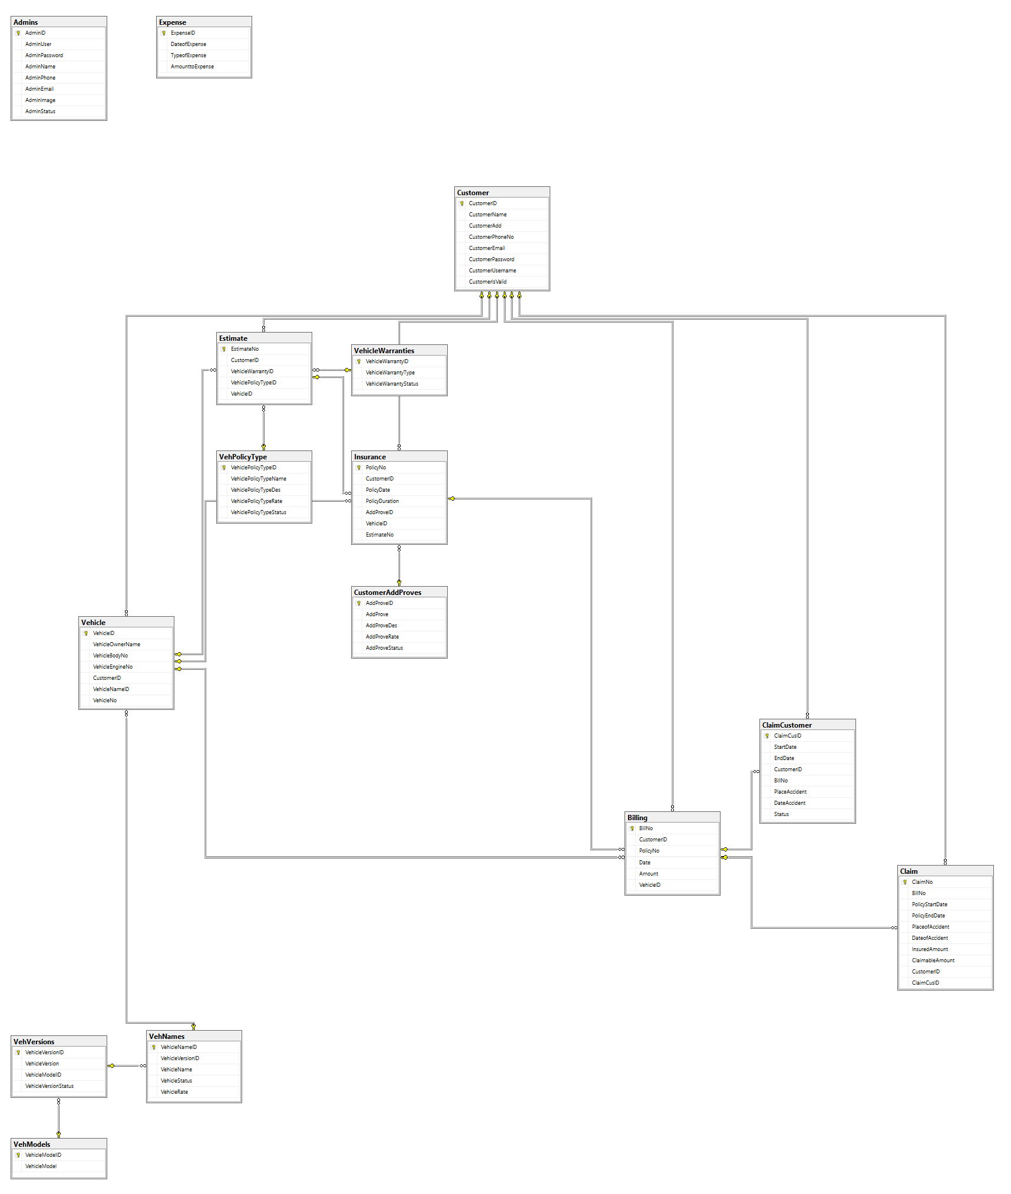

# USE CASE

## Static page



## Customer



## Admin



# SEQUENCE DIAGRAM

## Login



## Customer



## Admin



# ALGORITHMS

## Login



## Customer



## Admin





# GUI STANDARDS DOCUMENT





# INTERFACE DESIGN DOCUMENT

## Home page

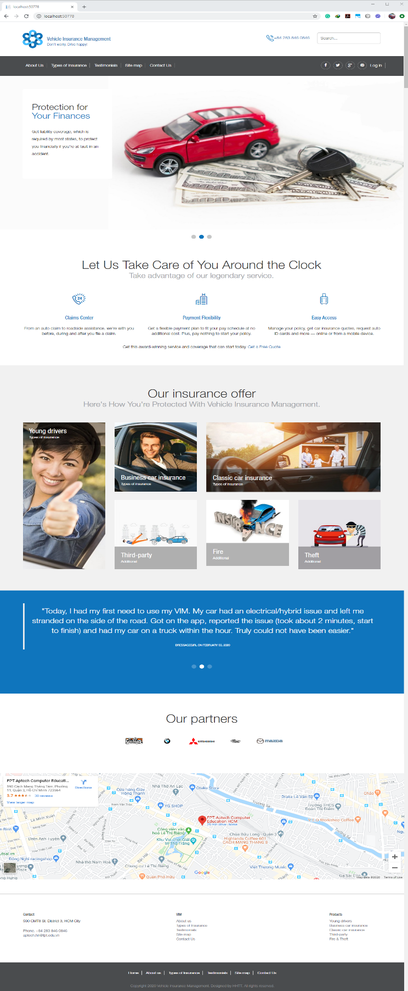Static page shows all information in one page.

* Navigation menu
* Slide show
* Types of Insurance
* Testimonials
* Our partners
* Map

## About Us

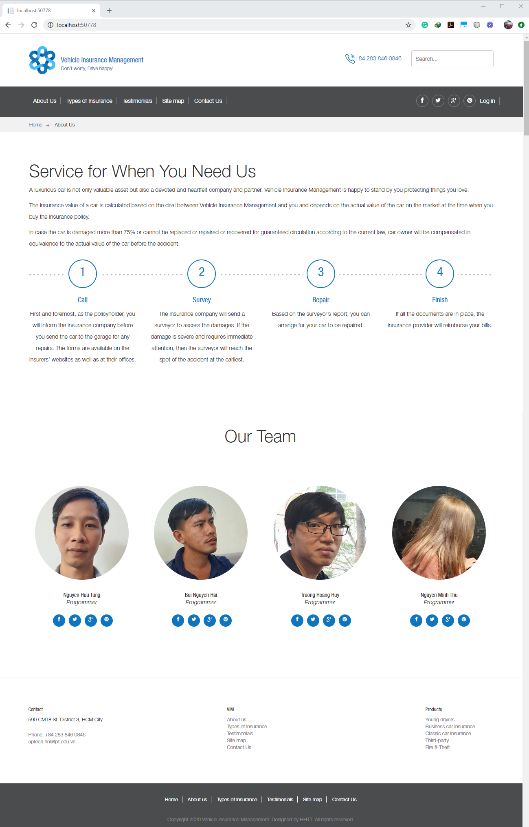

## Types of Insurance

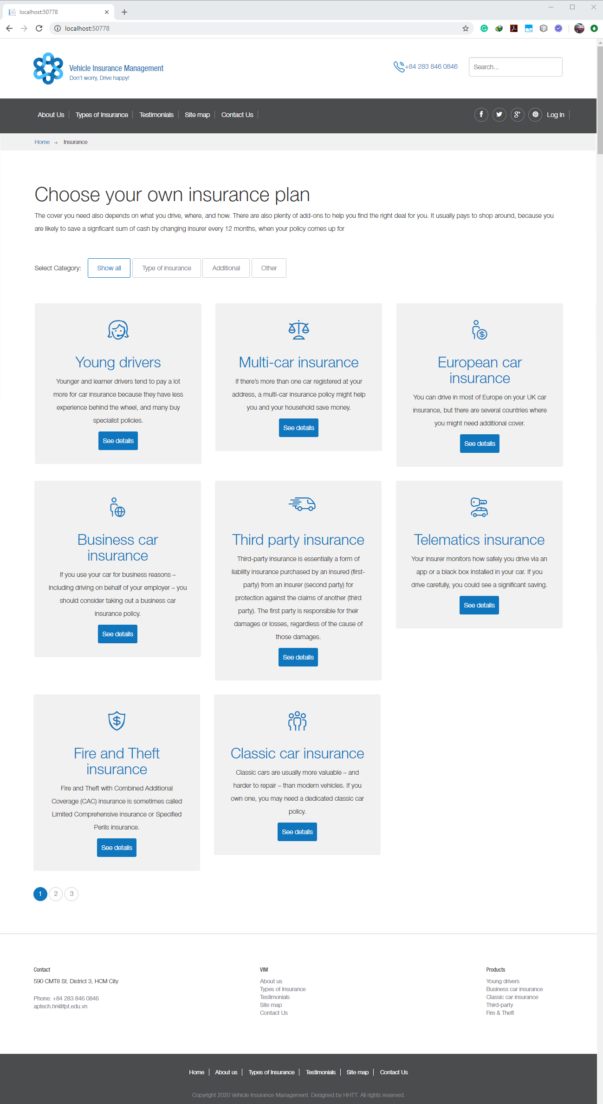

## Testimonials

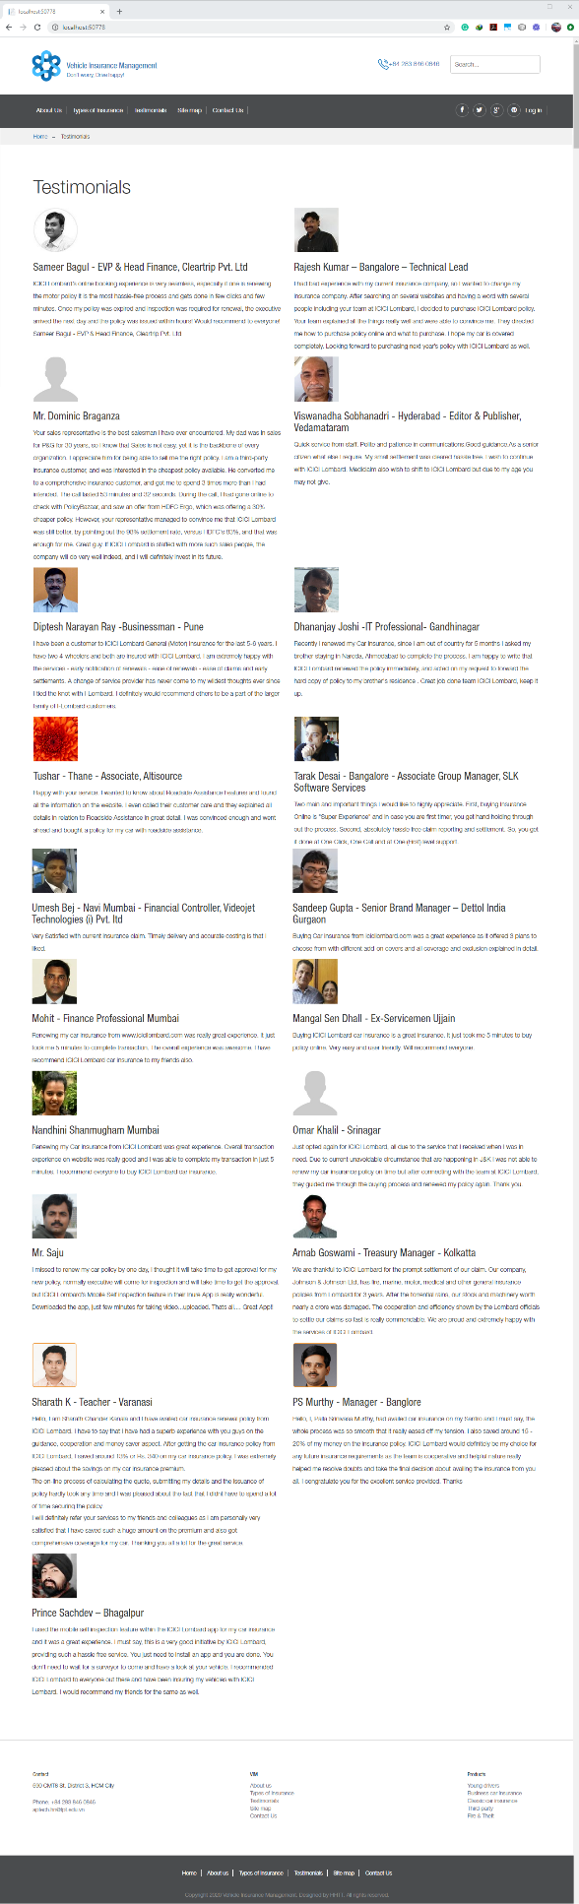

## Site map

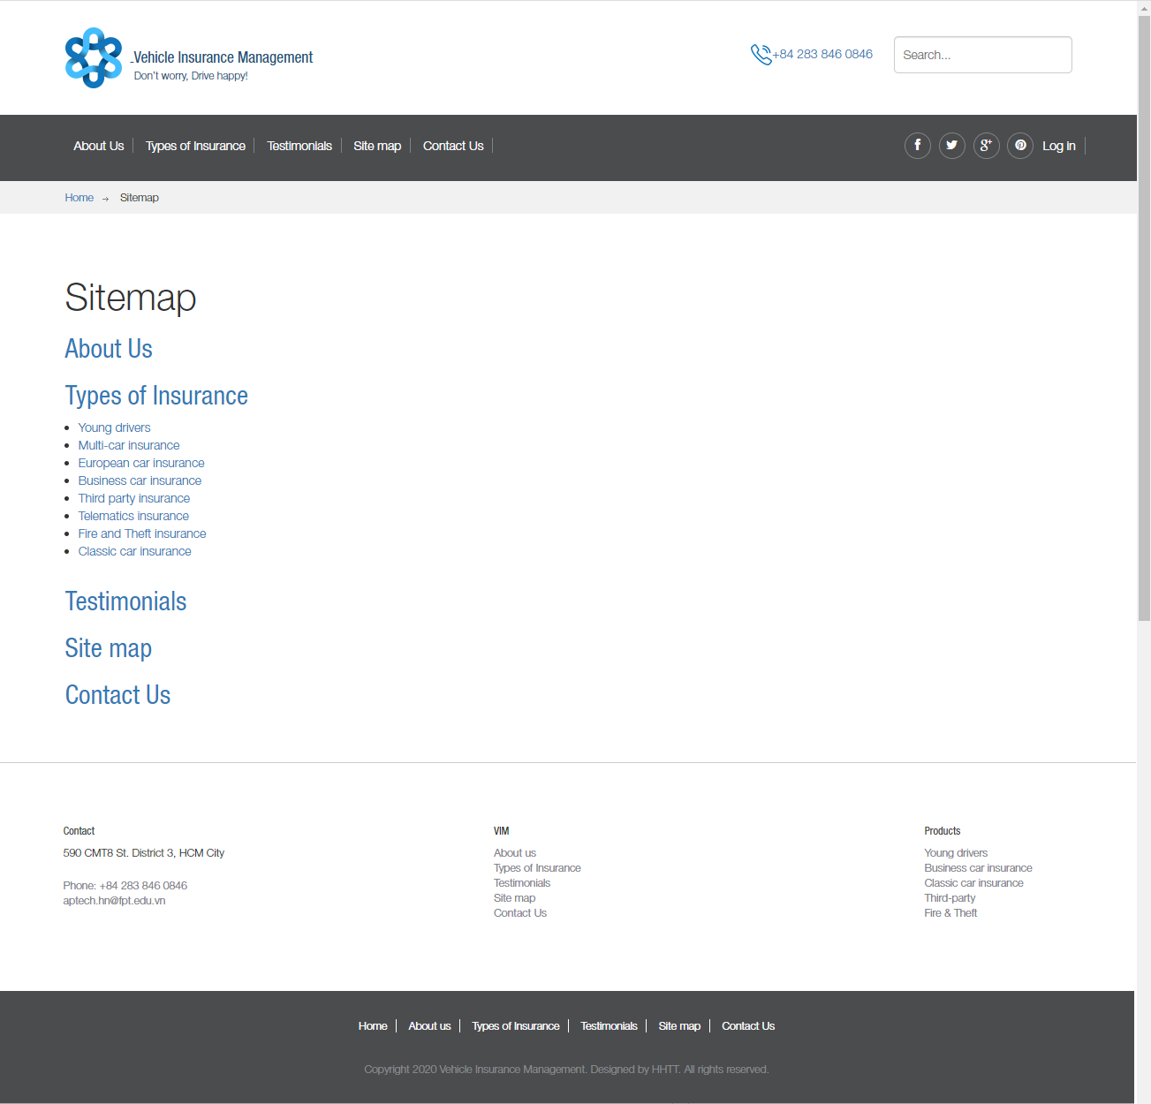

## Contact Us

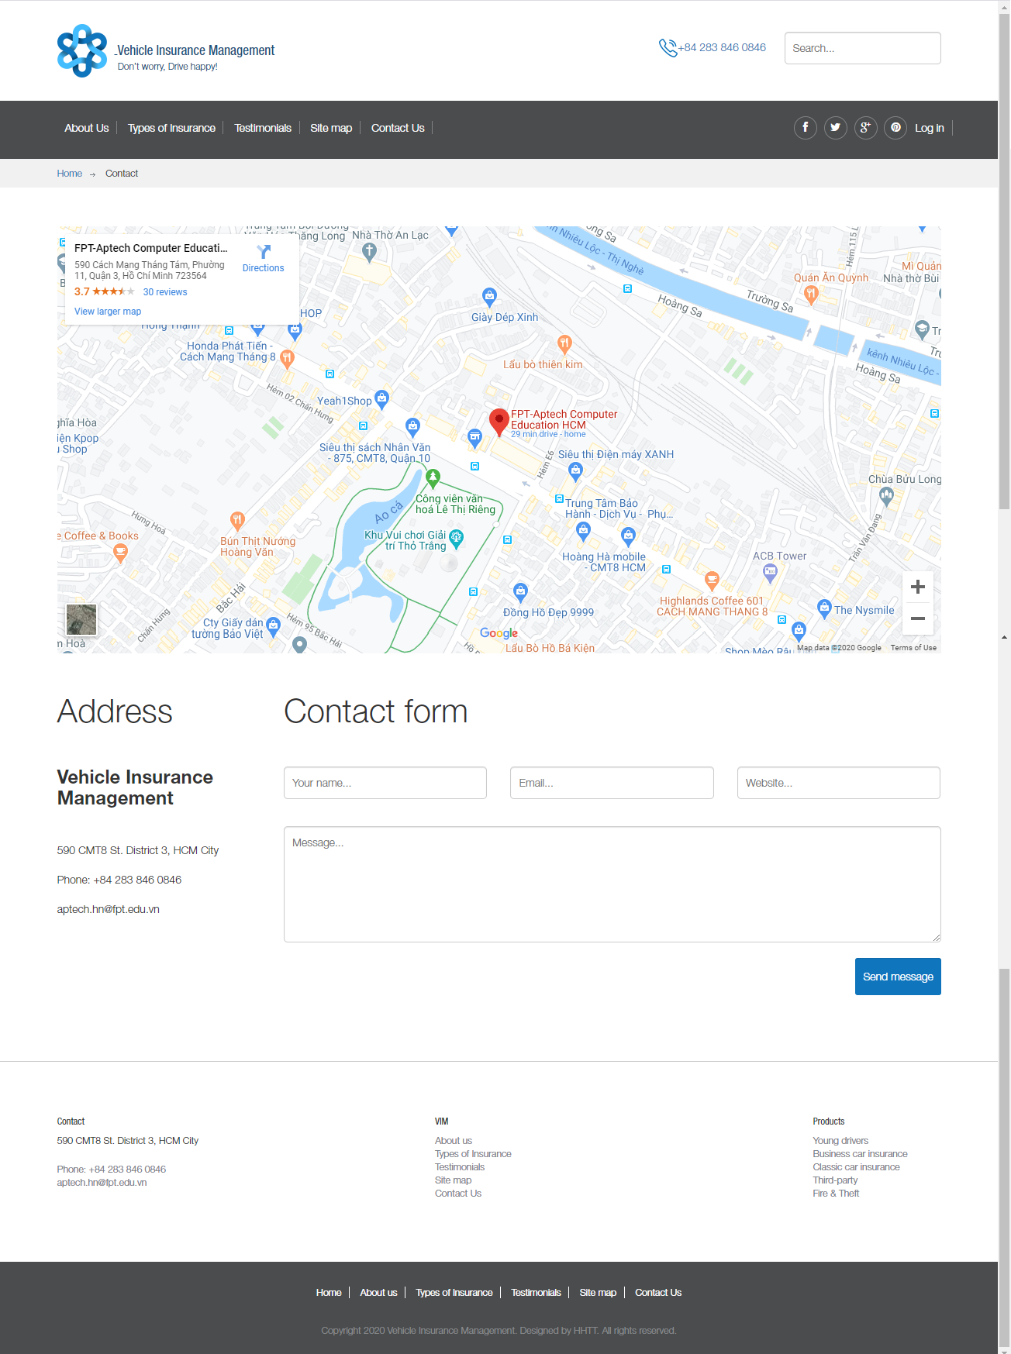

## Customer – Login | Register | Forget Password

### Login

The customer can login by username & password.

If you don’t have account yet, you can sign up and register new account. The new account must have activation from your email.

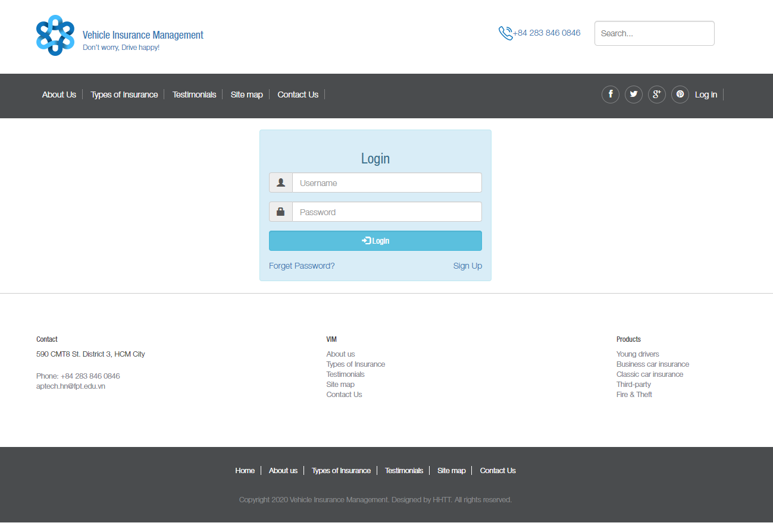

### Register

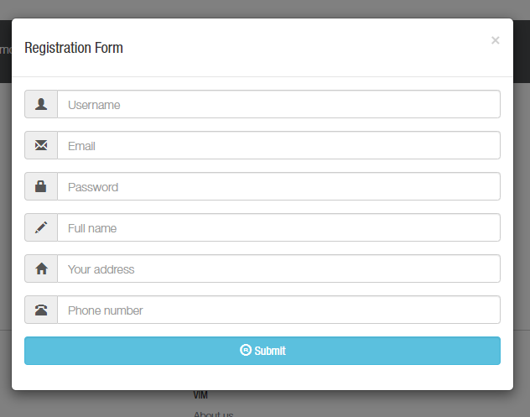

Email confirmation sent to email

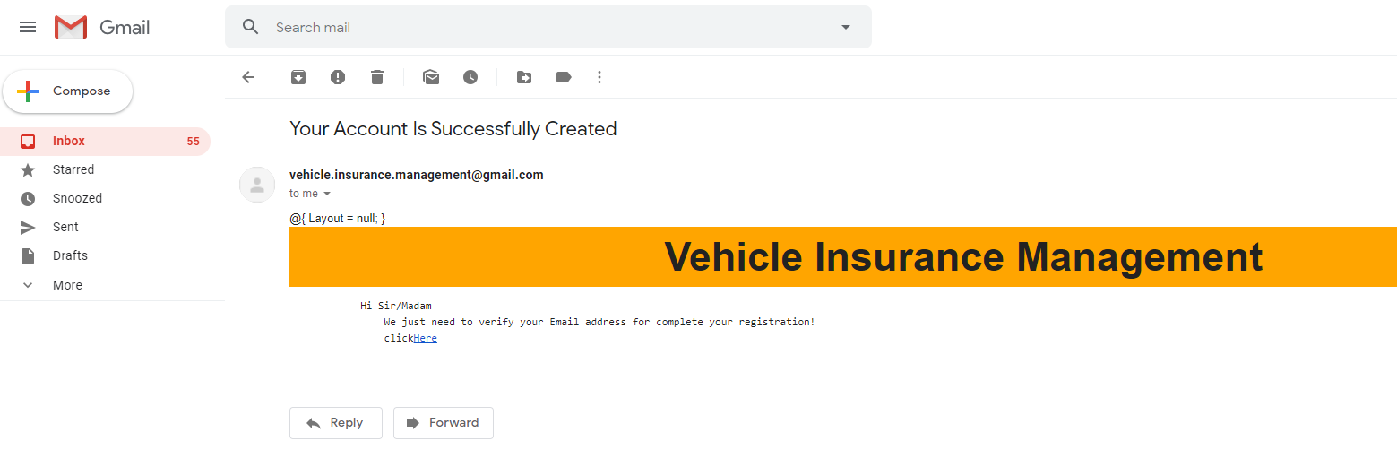

Confirm the email

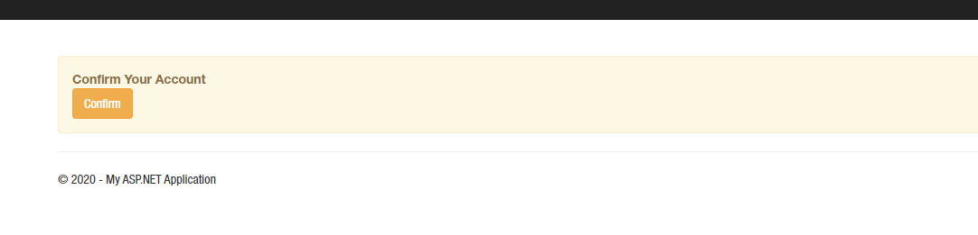

Email confirmed

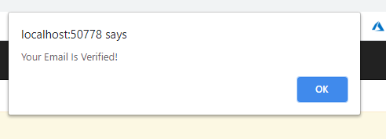

### Forget Password

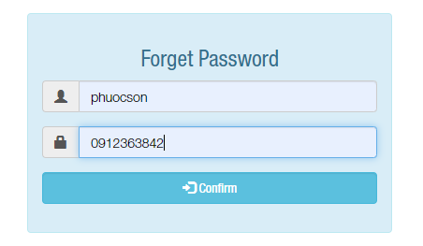

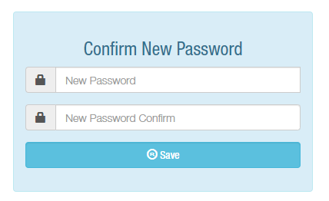

## Customer – profile

Registration information is unique and cannot be changed. The customer has only permission to change the password.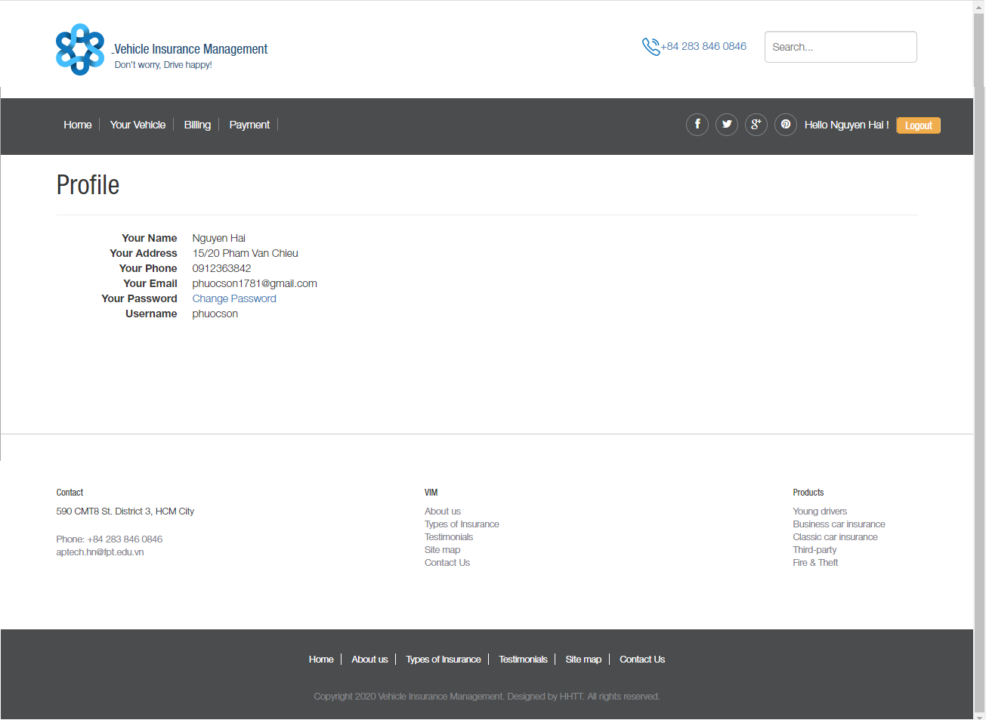

## Customer – Your vehicle

Features:

* New Vehicle: Create the new vehicle, customer can own multiple vehicles
* Create Estimate: Buy new insurance for vehicle. Each vehicle can buy many insurance
* Details: Show all information about your vehicle include:
  + Owner name
  + Model
  + Version
  + Name
  + Price
  + Body number
  + Engine number

## 

### Create new vehicle

Which create new vehicle, all the field will depend on validation.

Choose turn in order: Vehicle Mode 🡪 Vehicle Version 🡪 Vehicle.

Vehicle Rate will automatically show up.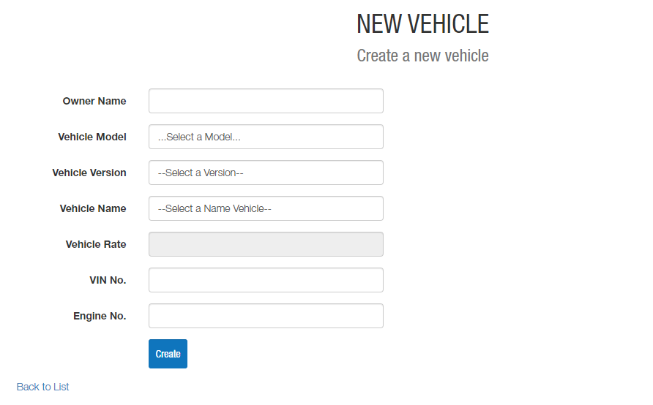

### Create estimate

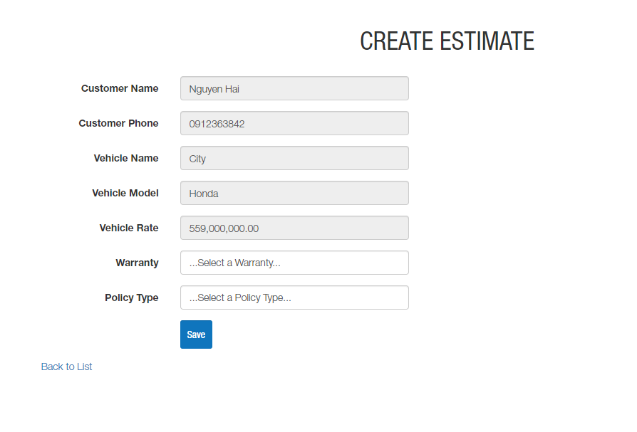

### Create insurance

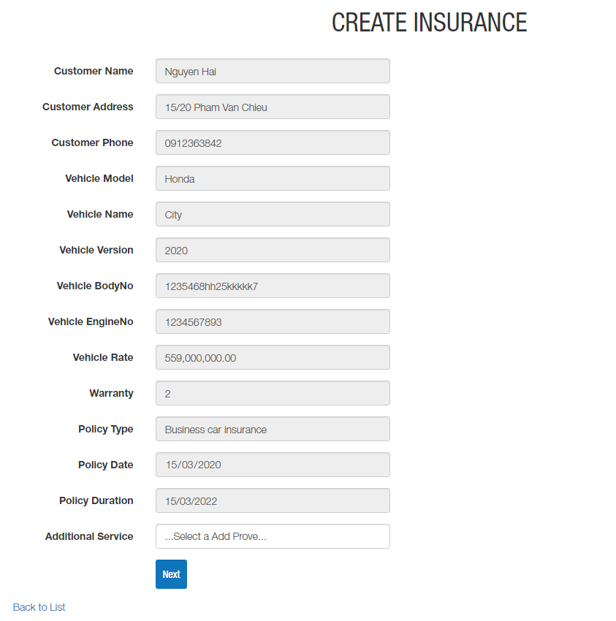

### Create Billing policy

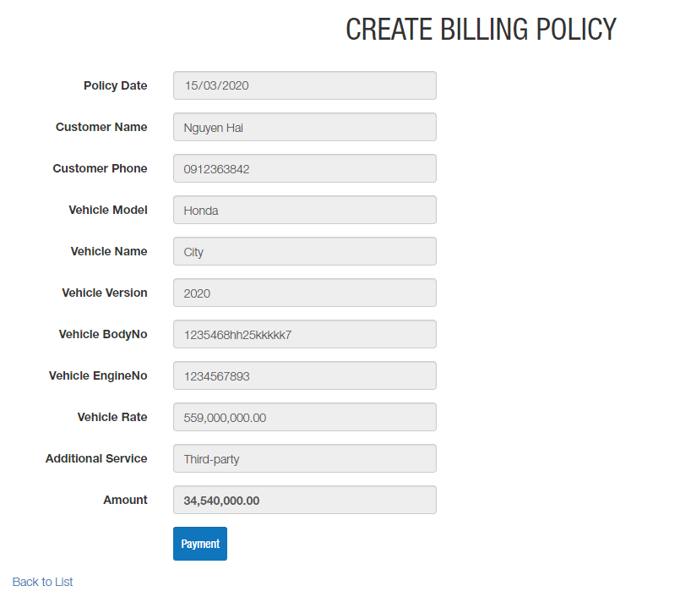

## Customer – Billing

Features:

* Details: Show all information about your insurance.
* Claim: Create the insurance claims payment process.

If any insurance for vehicle expired, the customer will not request claim paynment, and the customer can see the insurance has expired.

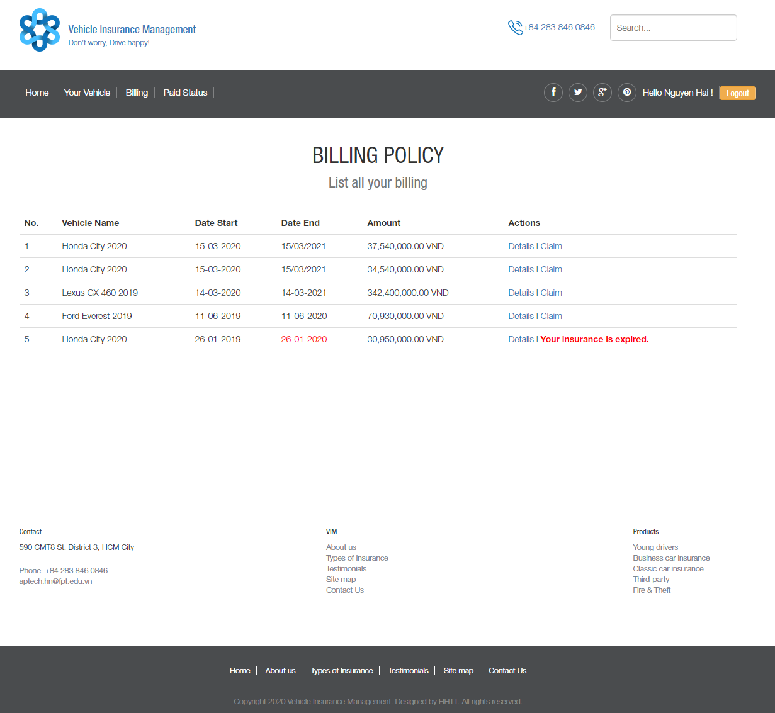

### Billing policy details

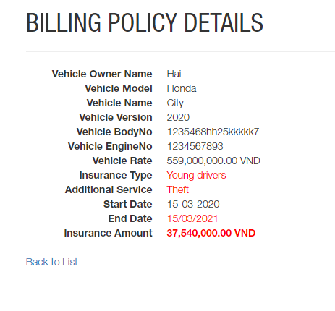

### Request a claim

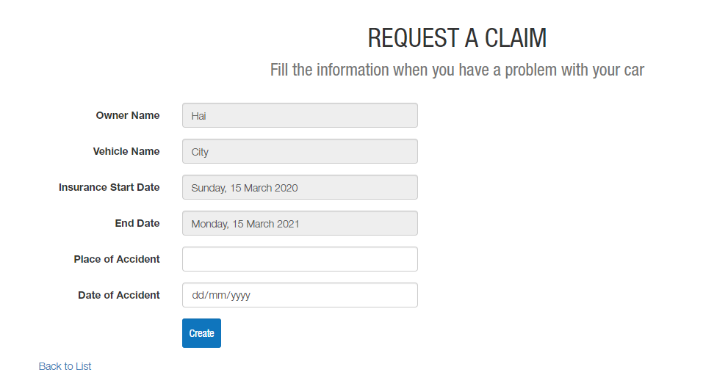

## Customer – Paid Status

The paid status show information about requisition payment when your vehicle has been an accident.

Which:

* **Completed**: the request has paid successfully
* **Reject**: the request do not eligible for compensation
* **Waiting**: the request waiting process from insurance company.

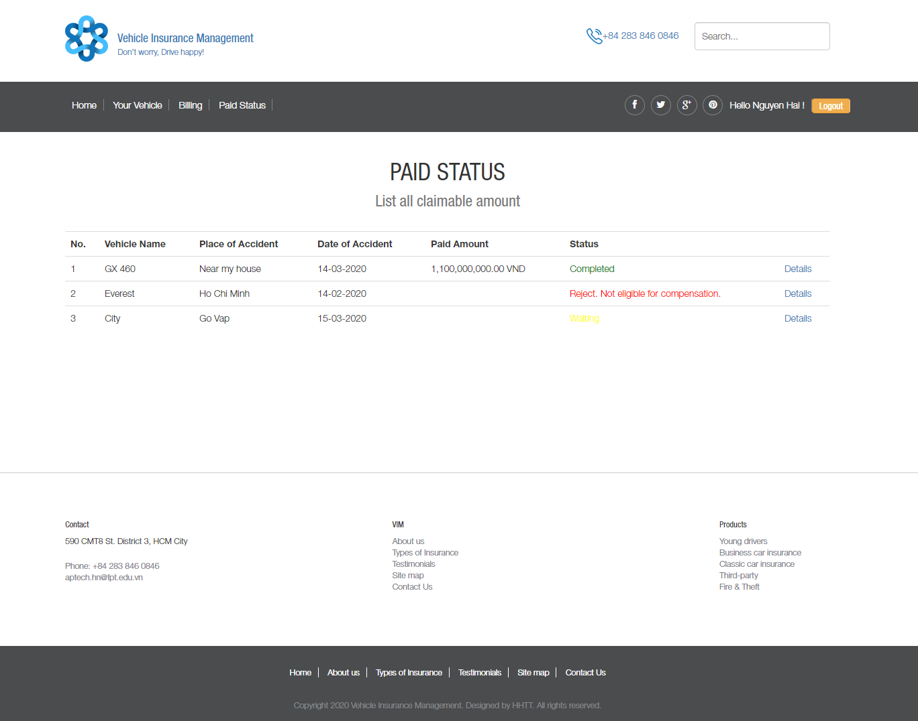

### Clam Details

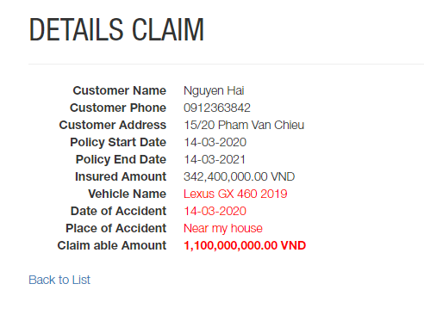 **Completed**

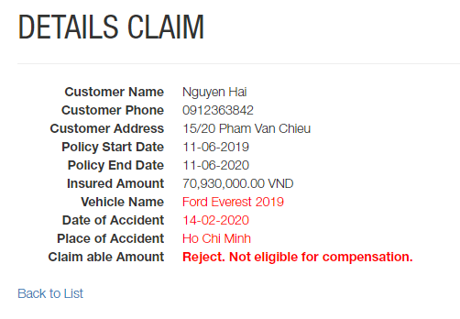 **Reject**

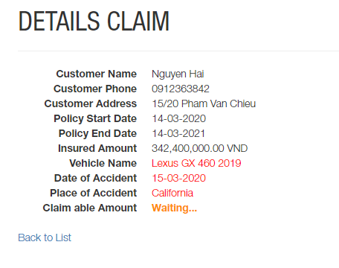 **Waiting…**

## Admin – Layout – Boxed

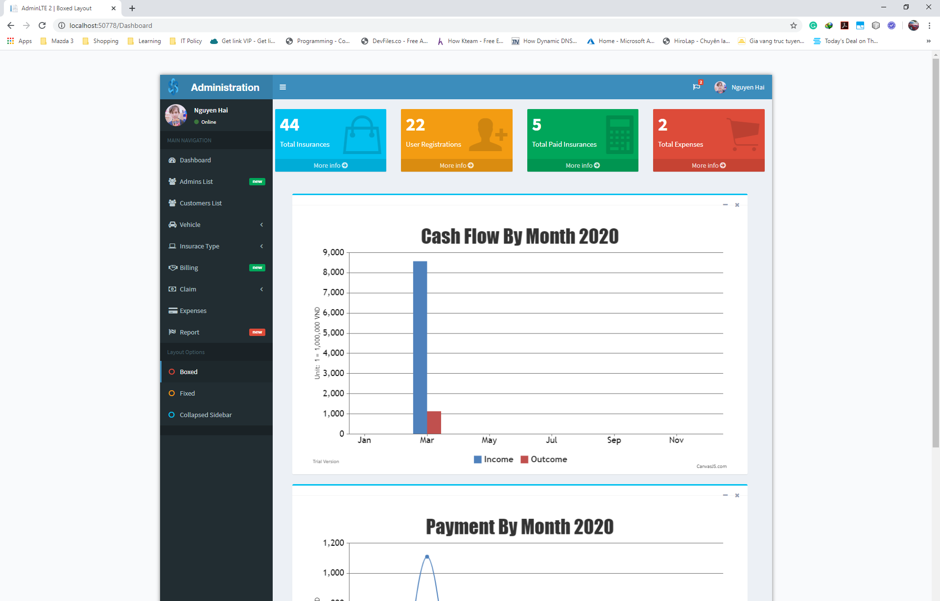

## Admin – Layout – Fixed

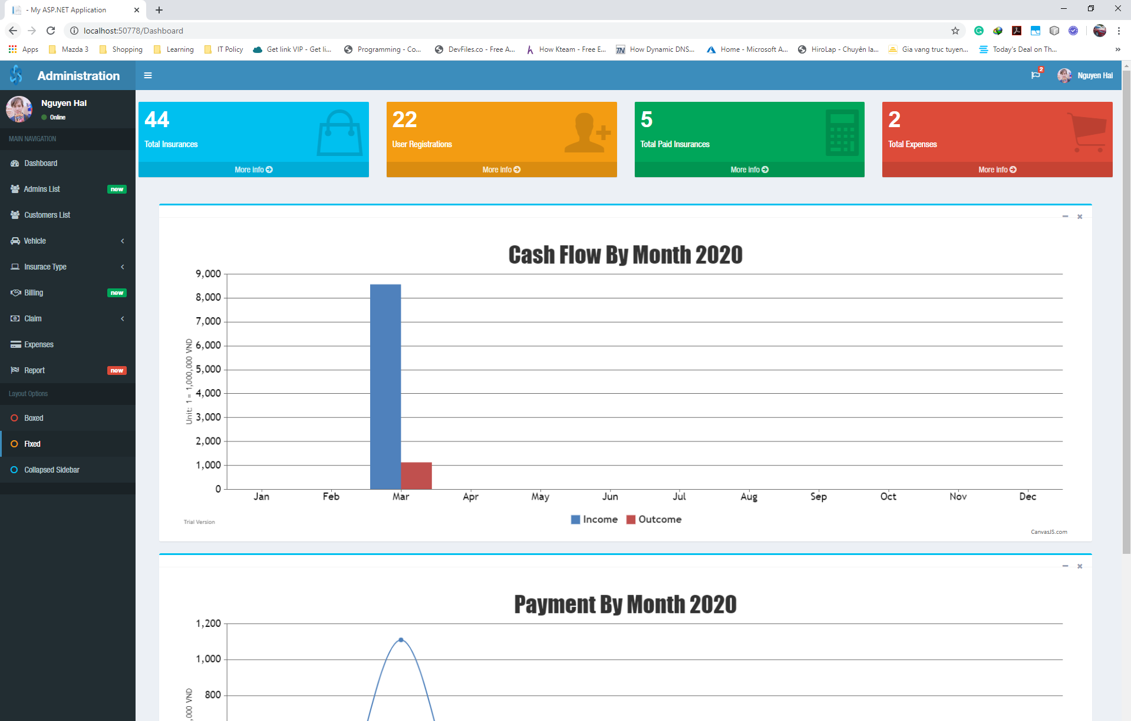

## Admin – Layout – Collapsed Sidebar

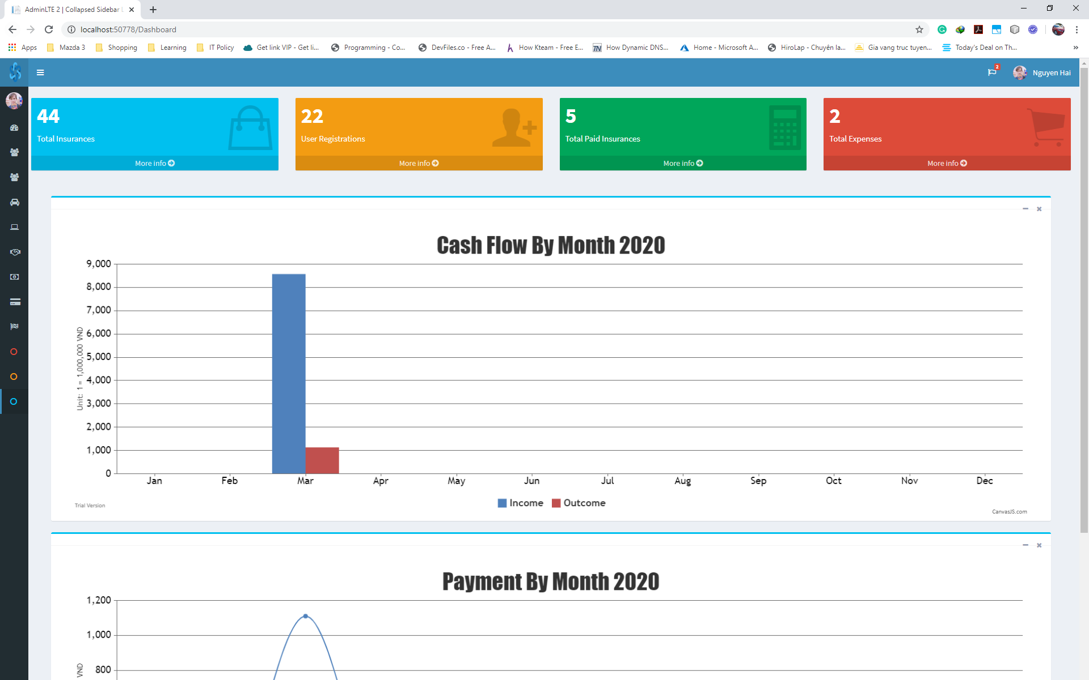

## Admin – Dashboard

Show the information about:

* Total Insurance
* User Registrations
* Total Paid Insurances
* Total Expenses

Show the map about cash flow and payment by monthly.

Navigation menu shows on the left of page

* Dashboard
* Admin List
* Customer List
* Vehicle
  + Vehicle List
  + Vehicle Model
  + Vehicle Version
  + Vehicle Name
* Insurance Type
  + Vehicle Warranty
  + Vehicle Policy Type
  + Add Prove
* Billing
* Claim
  + Process
  + Success
* Expenses
* Report

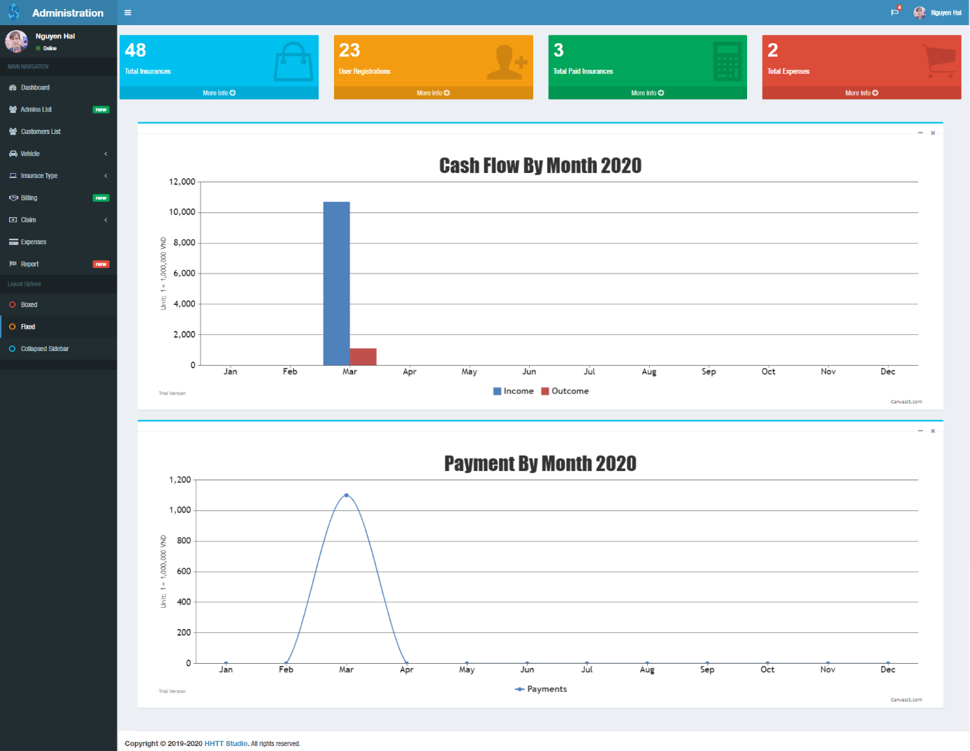

## Admin – Admin List

Feature:

* Create new
* Search by name
* Sort by fields and sort in search
* Edit | Detail

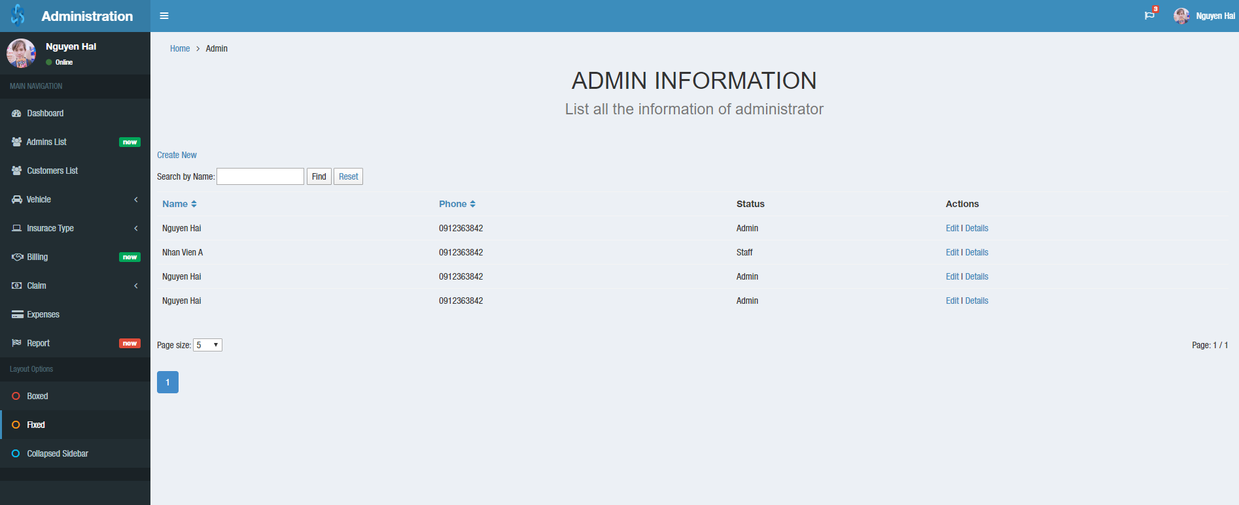

### Create new admin / staff

Status **admin**: you have all permission in admin template

Status **staff**:you don’t have permission create or edit admin account in Admin List menu.

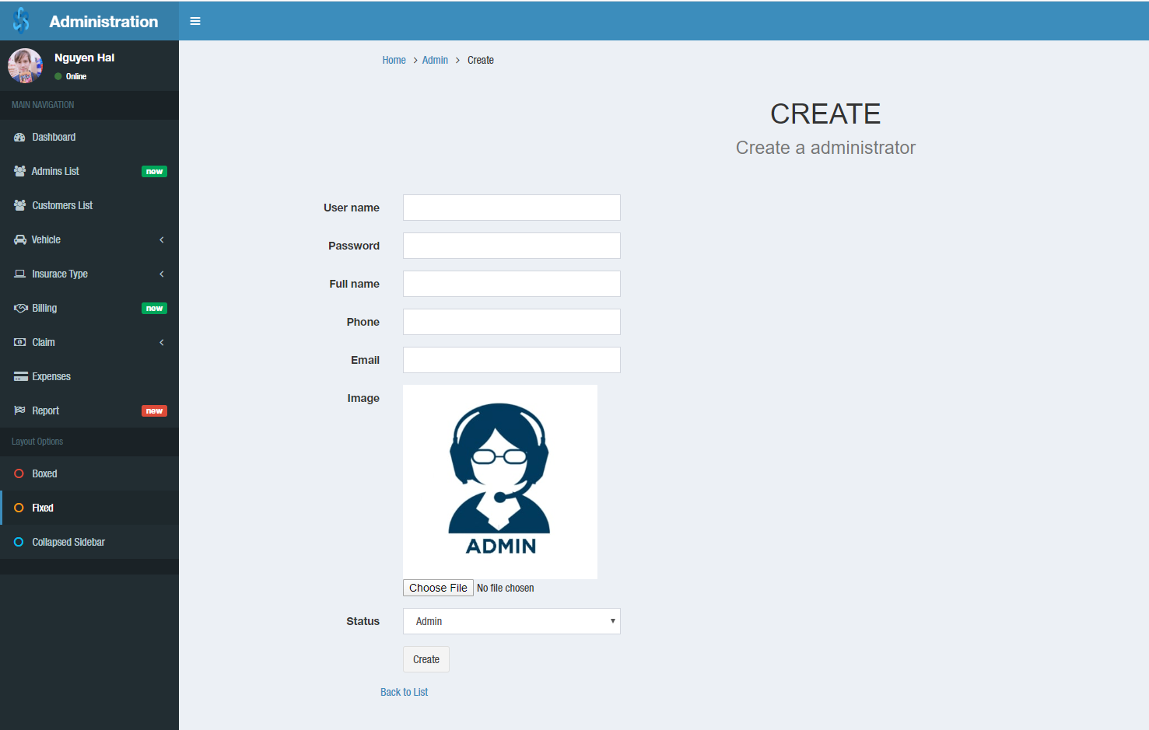

### Edit admin account

Admin can change Full name, phone, email and image

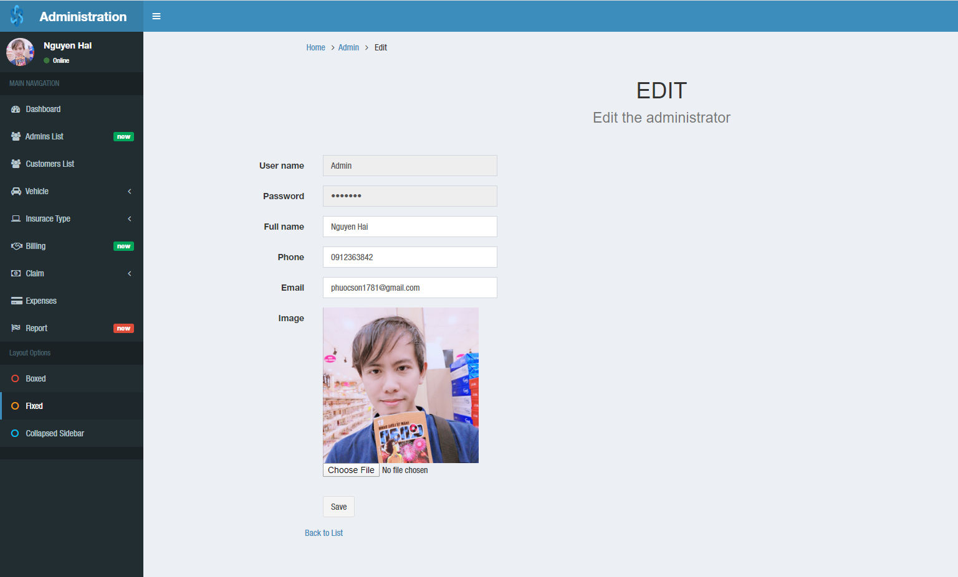

### Admin details

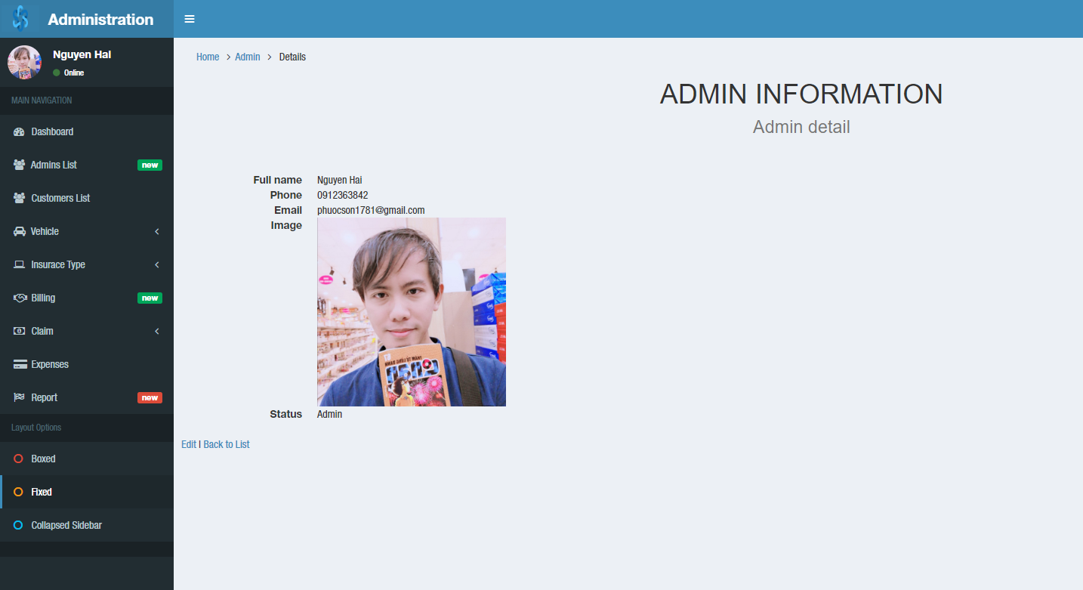

## Admin – Customer List

Feature:

* Create new customer
* Search by customer name
* Sort by fields and sort in search
* Show the row number on a page
* Page1, 2, 3, …
* Create Vehicle
* Detail

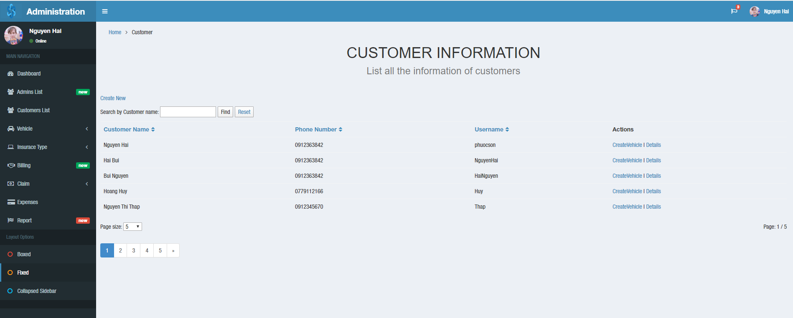

### Create new customer

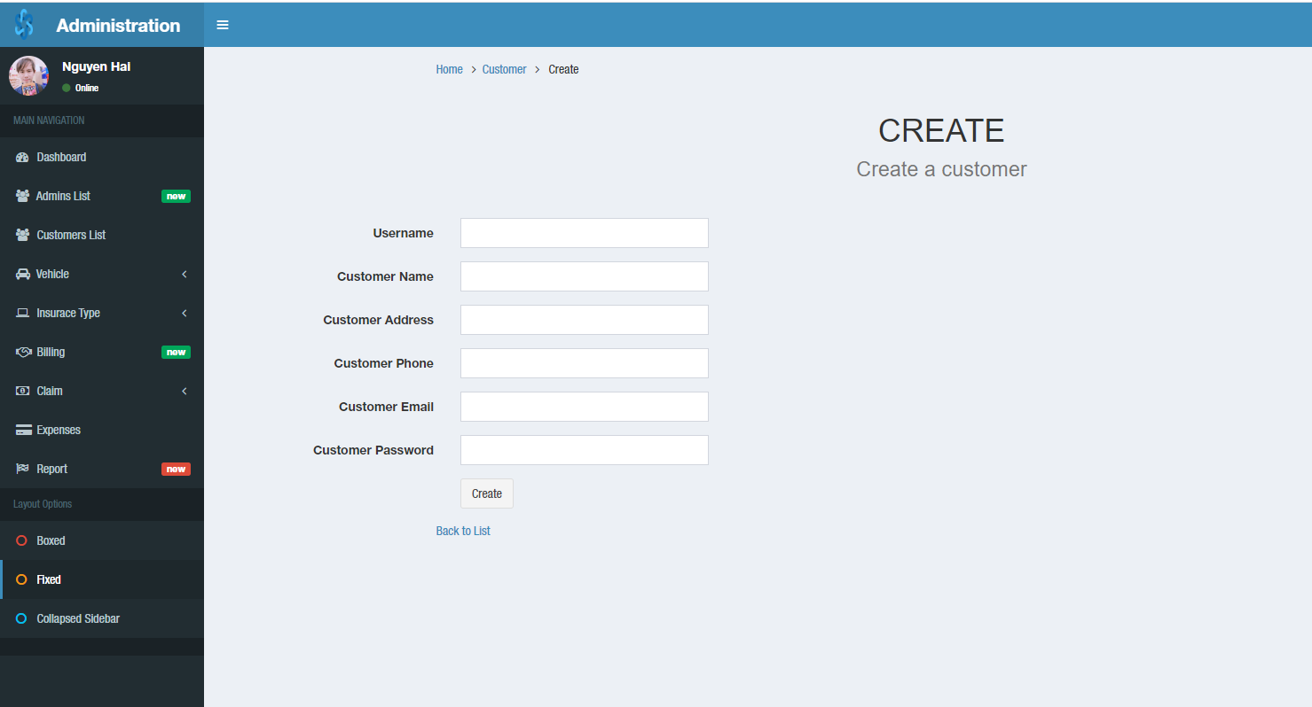

### Create new vehicle

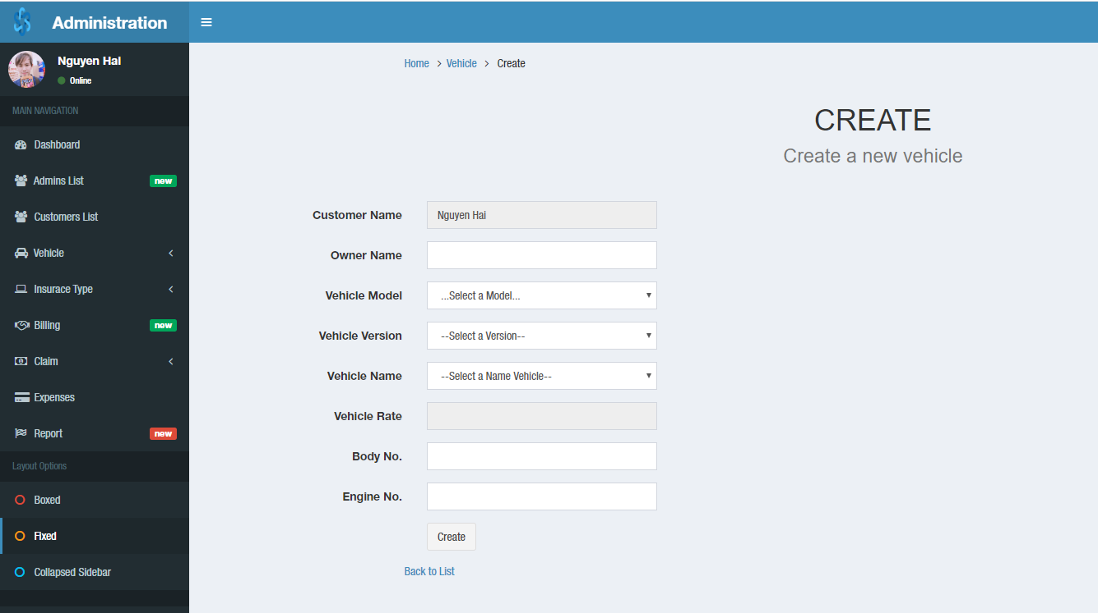

### Customer details

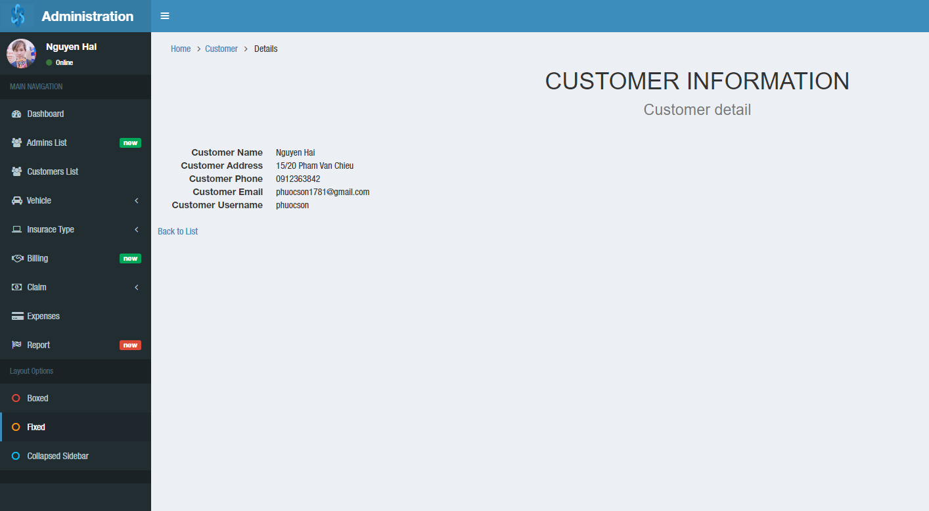

## Admin – Vehicle – Vehicle List

Feature:

* Search by owner name
* Show the row number on a page
* Page1, 2, 3, …
* Edit | Detail

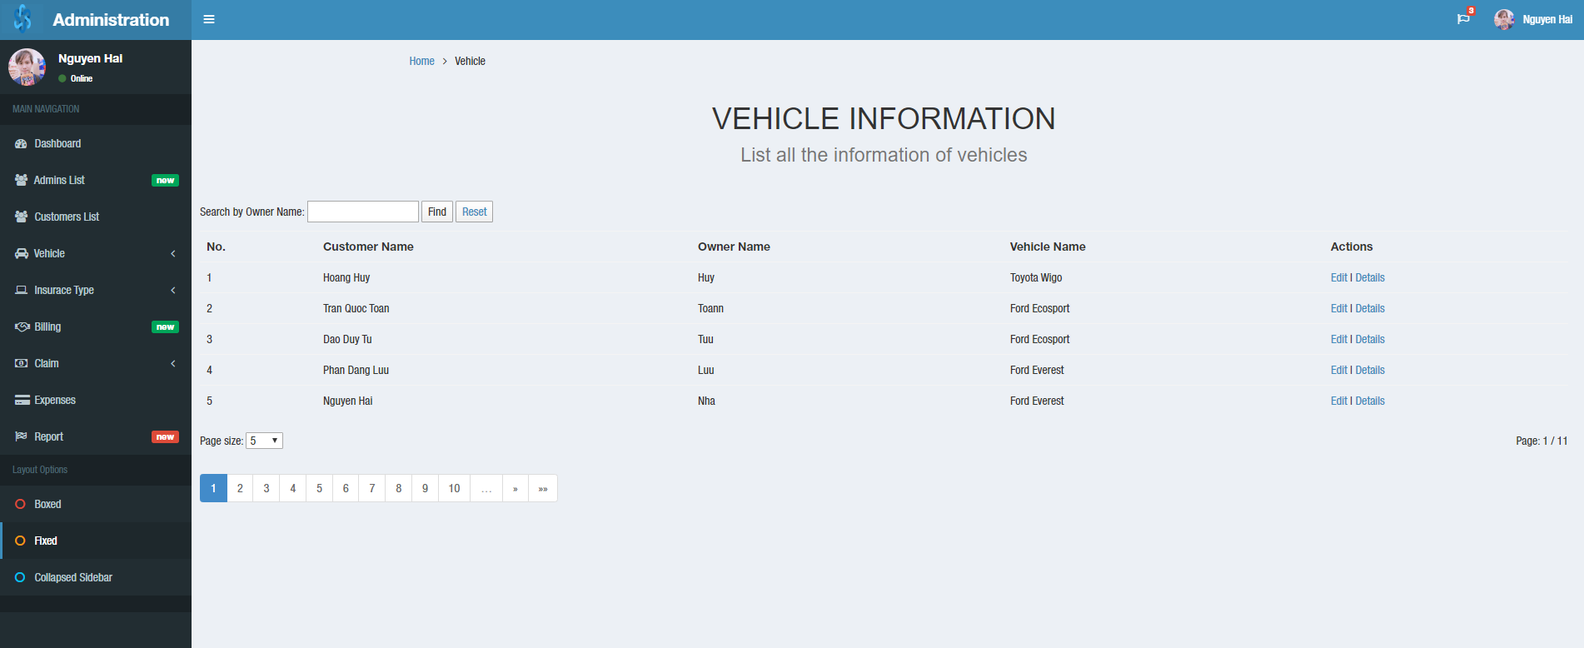

### Vehicle edits

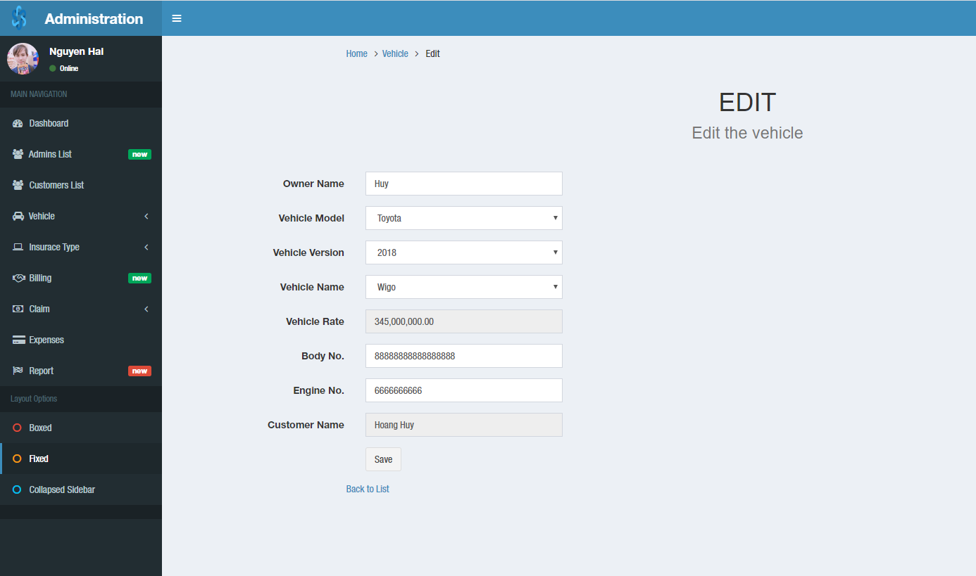

### Vehicle details

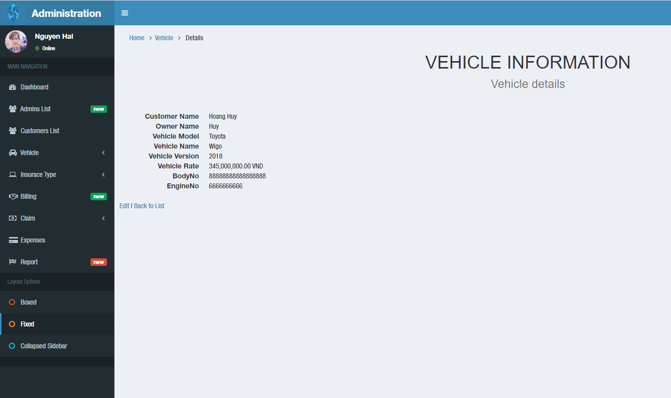

## Admin – Vehicle – Vehicle Model

Feature:

* Create new
* Create Version
* Edit

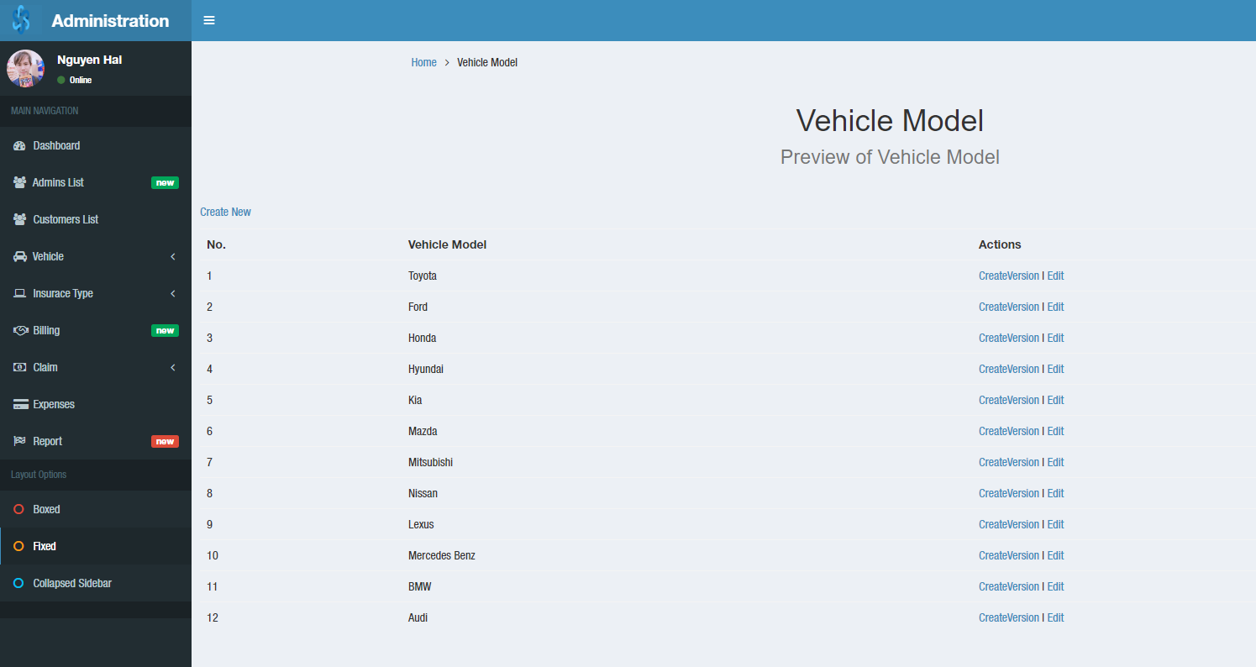

### Create new model

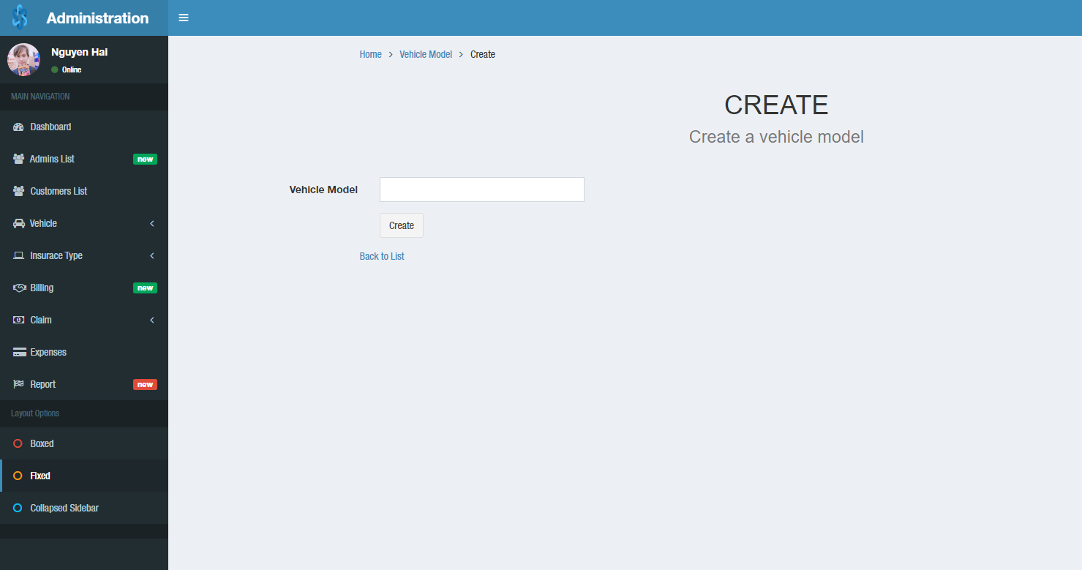

### Create vehicle version

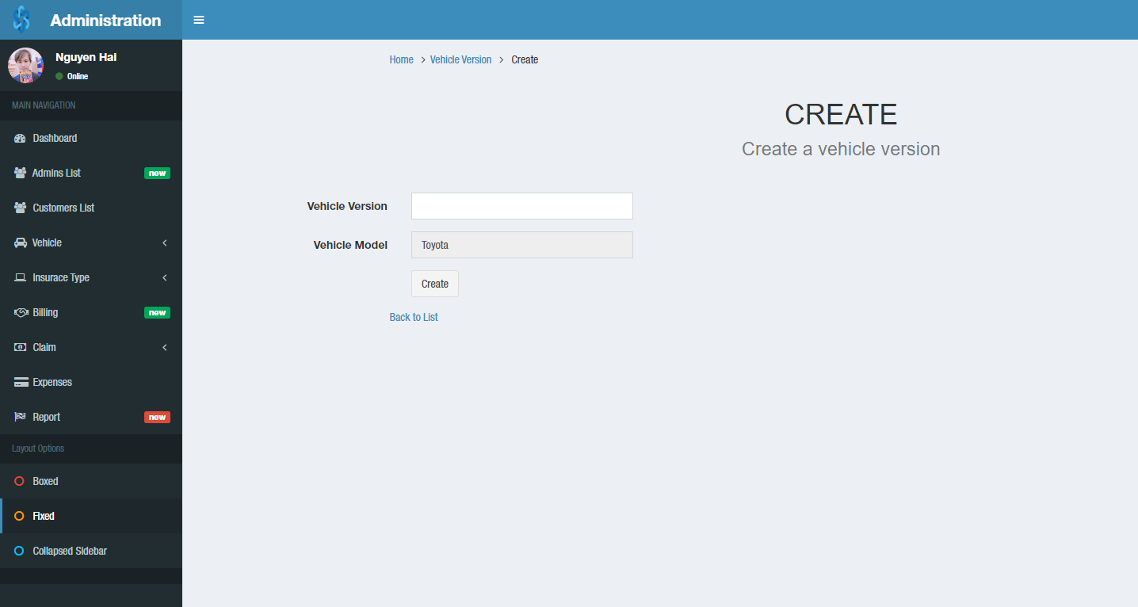

### Edit vehicle model

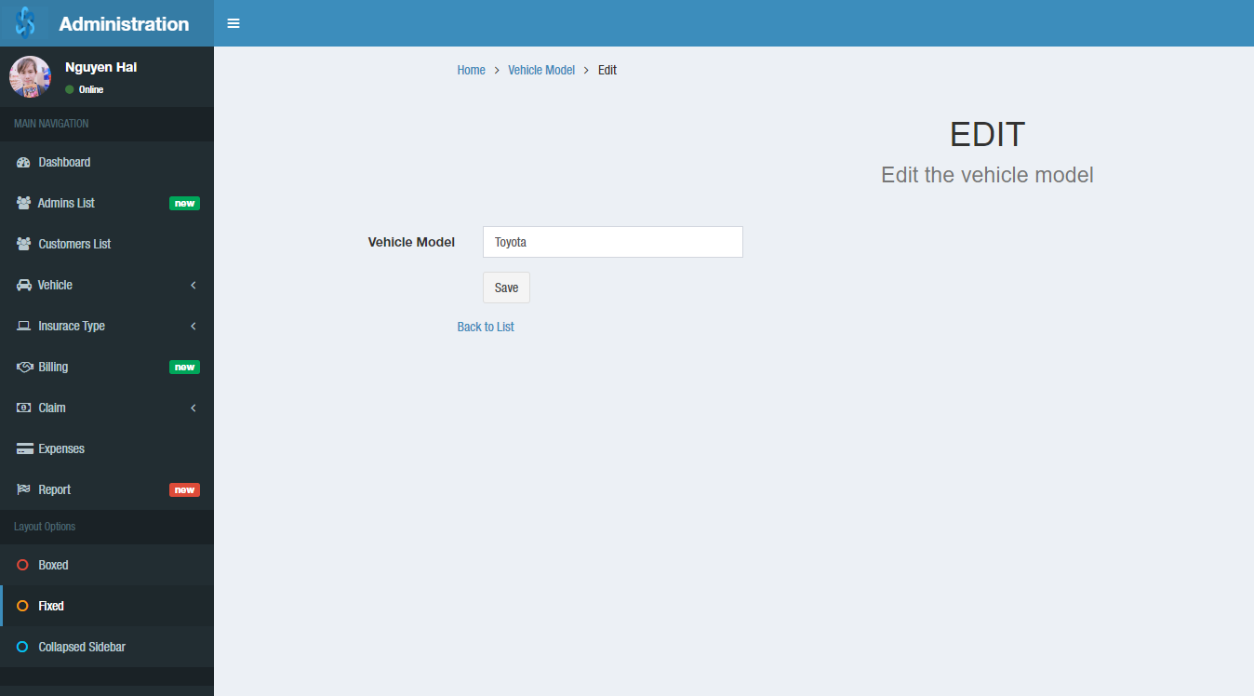

## Admin – Vehicle – Vehicle Version

Feature:

* Create Vehicle Name
* Edit

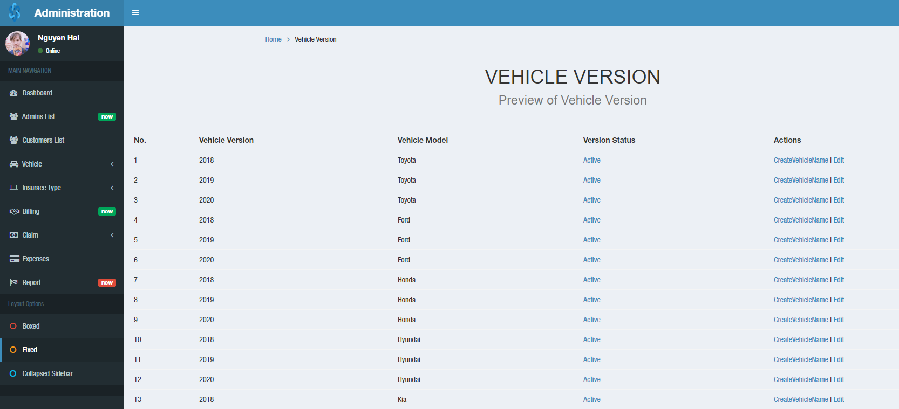

### Create vehicle name

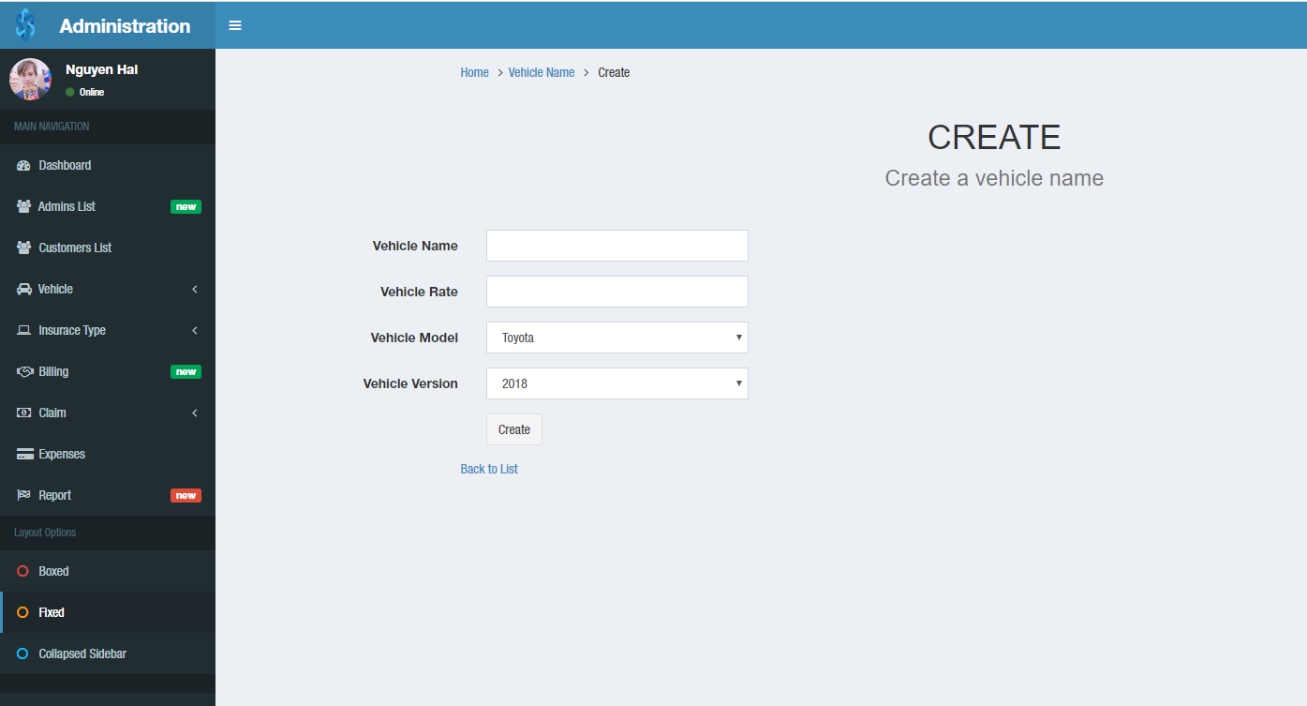

### Edit vehicle version

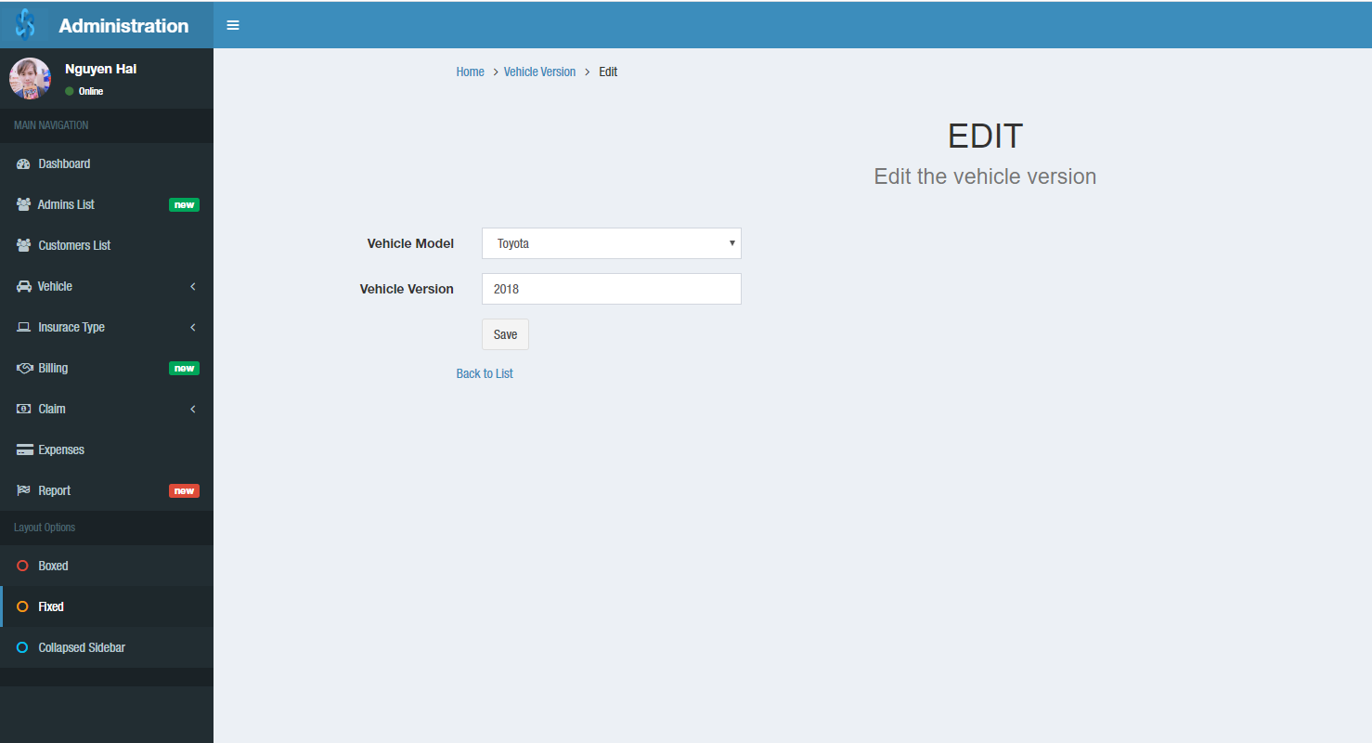

### Version Status

Feature:

* Active / Archive vehicle version status

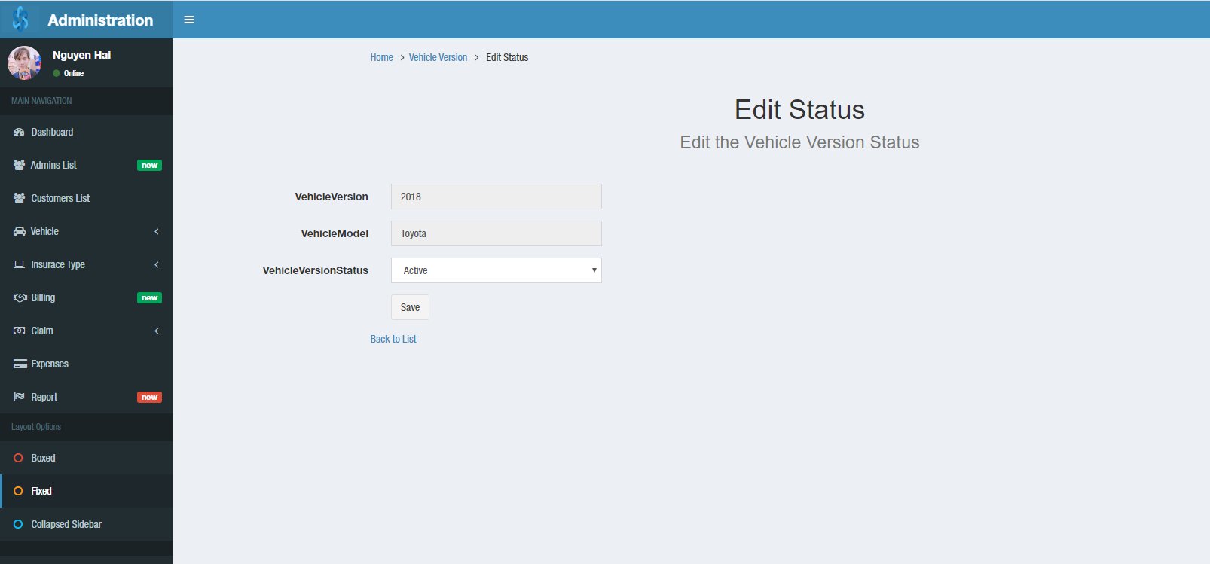

## Admin – Vehicle – Vehicle Name

Feature:

* Search by vehicle name
* Sort by fields and sort in search
* Show the row number on a page
* Page1, 2, 3, …
* Edit | Detail

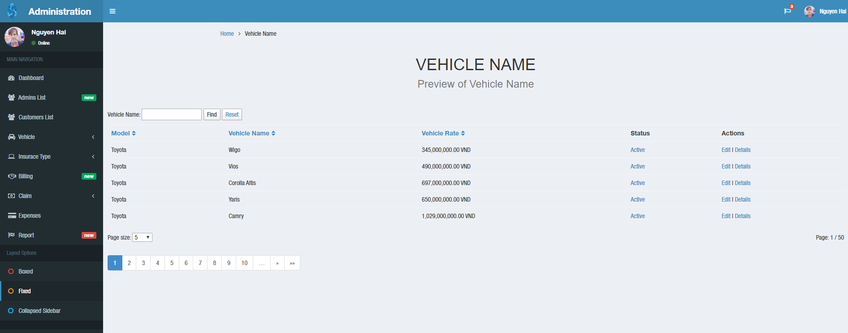

### Edit vehicle name

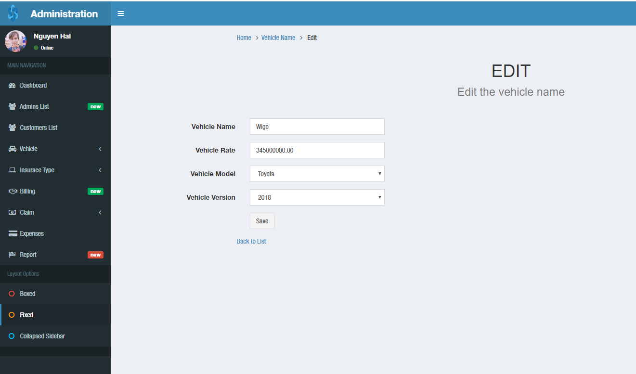

### Vehicle name details

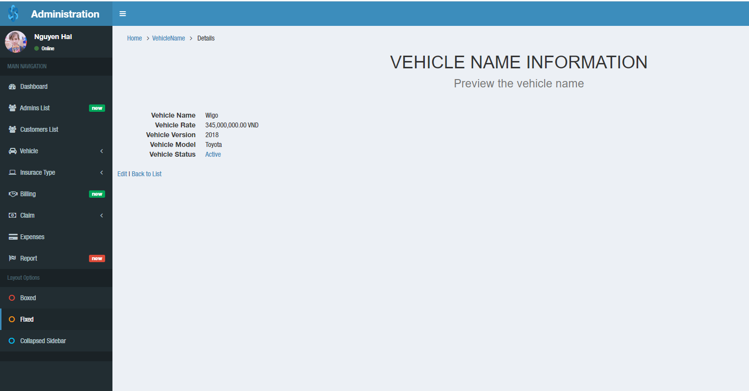

### Vehicle name Status

Feature:

* Active / Archive vehicle name status

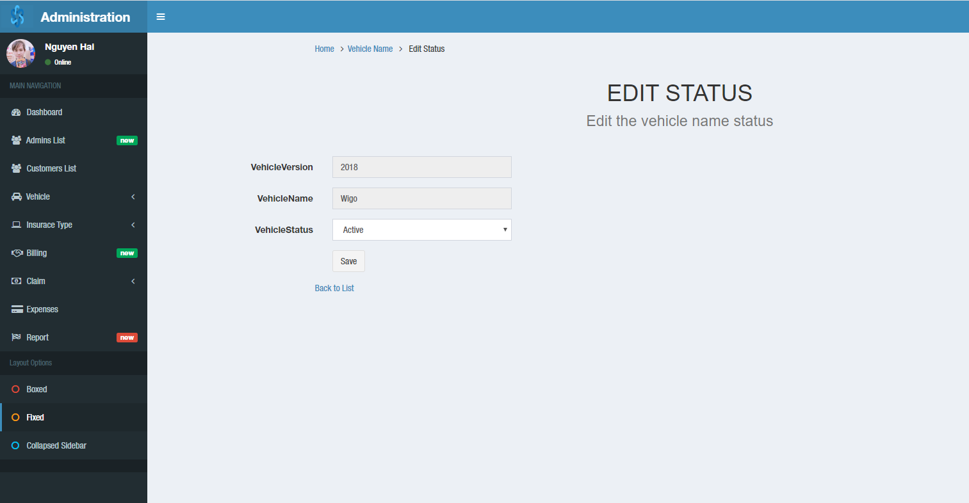

## Admin – Insurance Type – Vehicle Warranty

Feature:

* Create new
* Edit

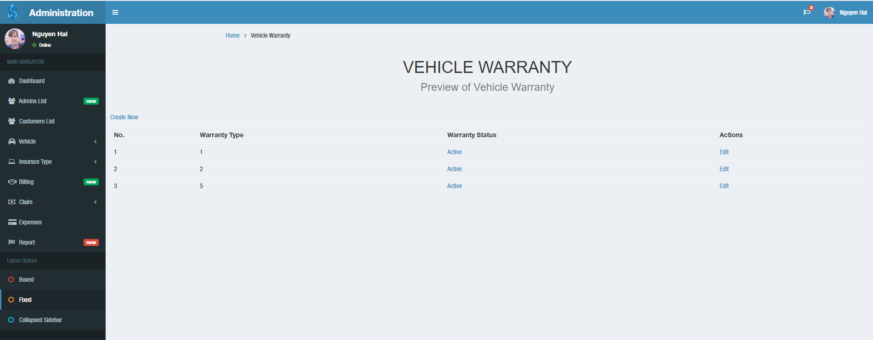

### Edit Vehicle warranty

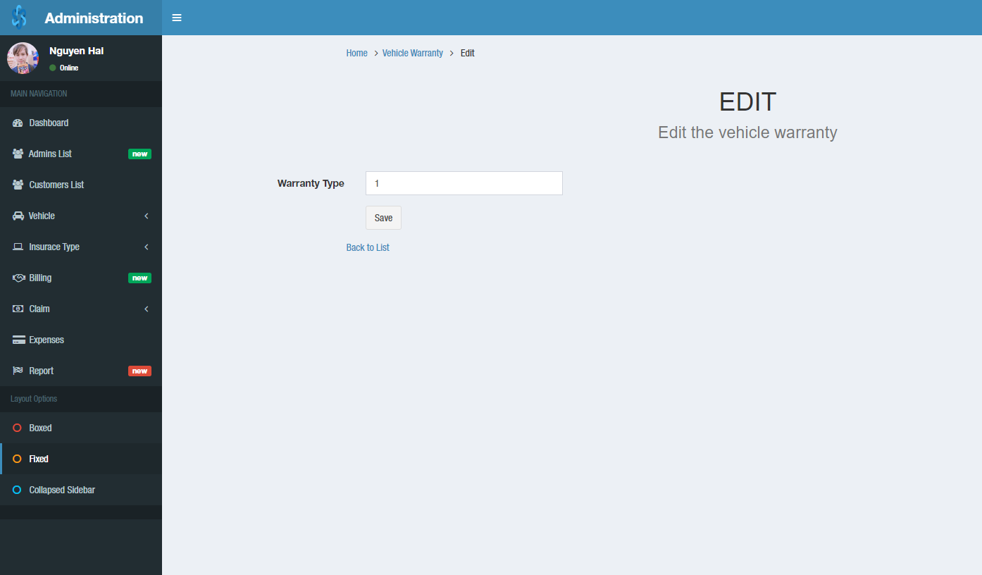

### Vehicle warranty status

Feature:

* Active / Archive vehicle warranty status

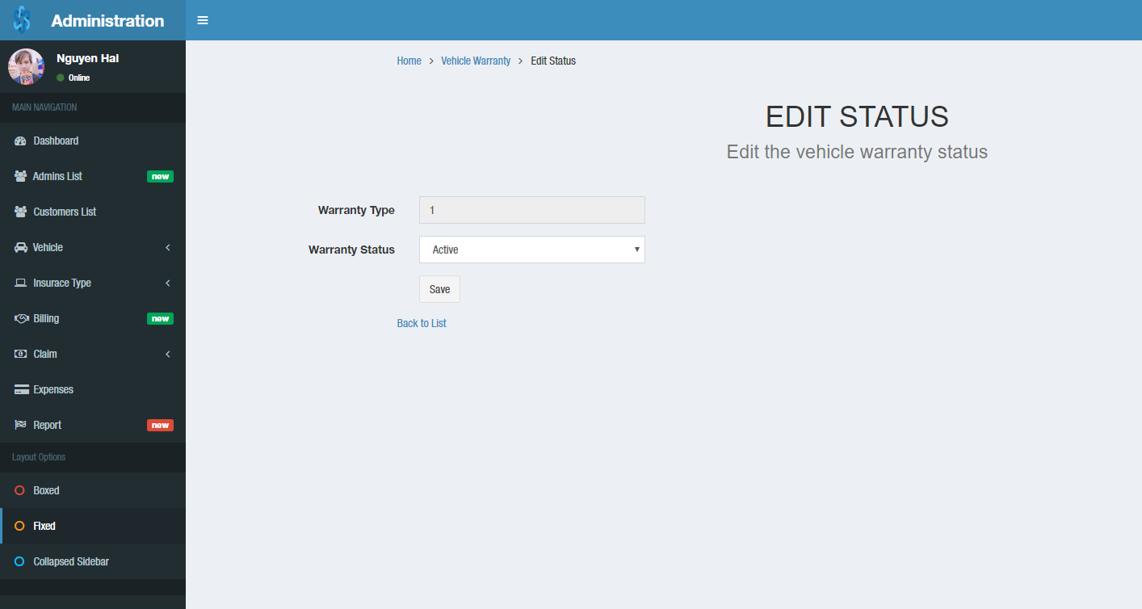

## Admin – Insurance Type – Vehicle Policy Type

Feature:

* Create new
* Edit
* Detail

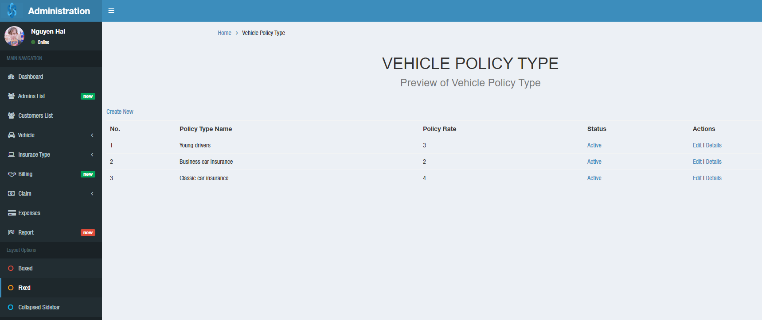

### Edit Vehicle policy type

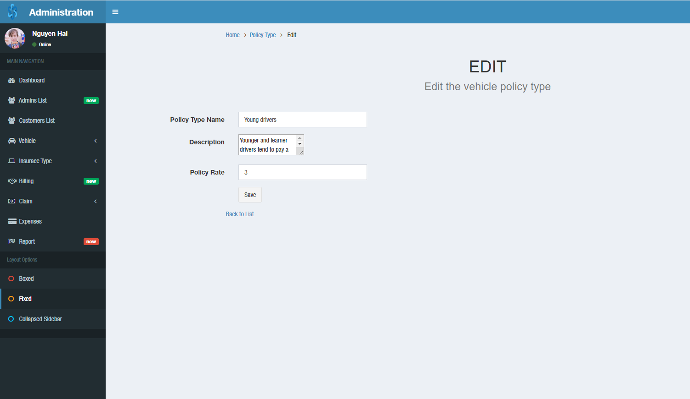

### Vehicle policy type details

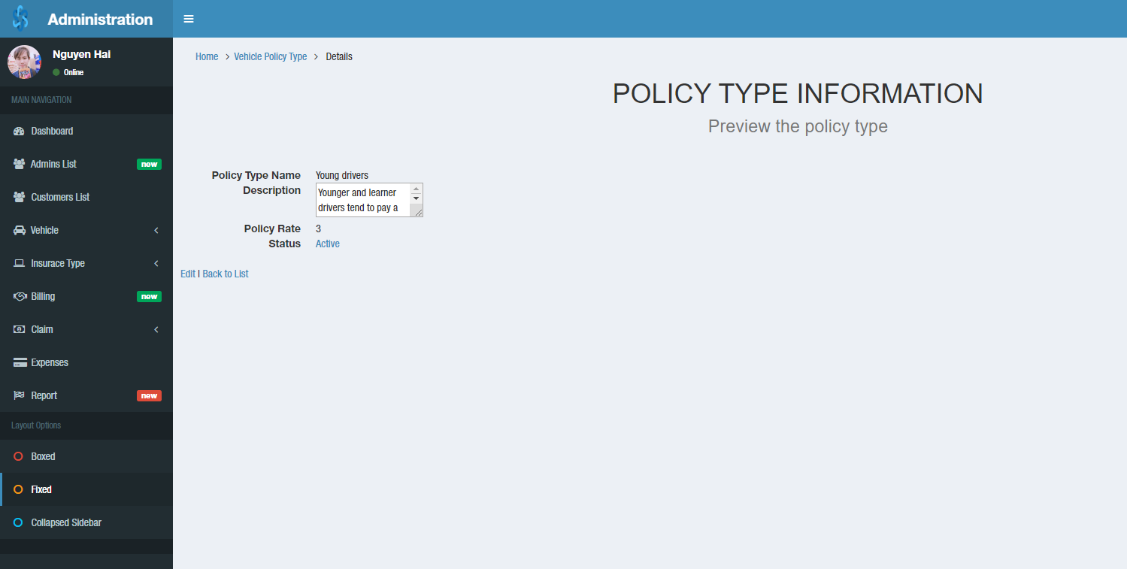

### Vehicle policy status

Feature:

* Active / Archive vehicle policy type status

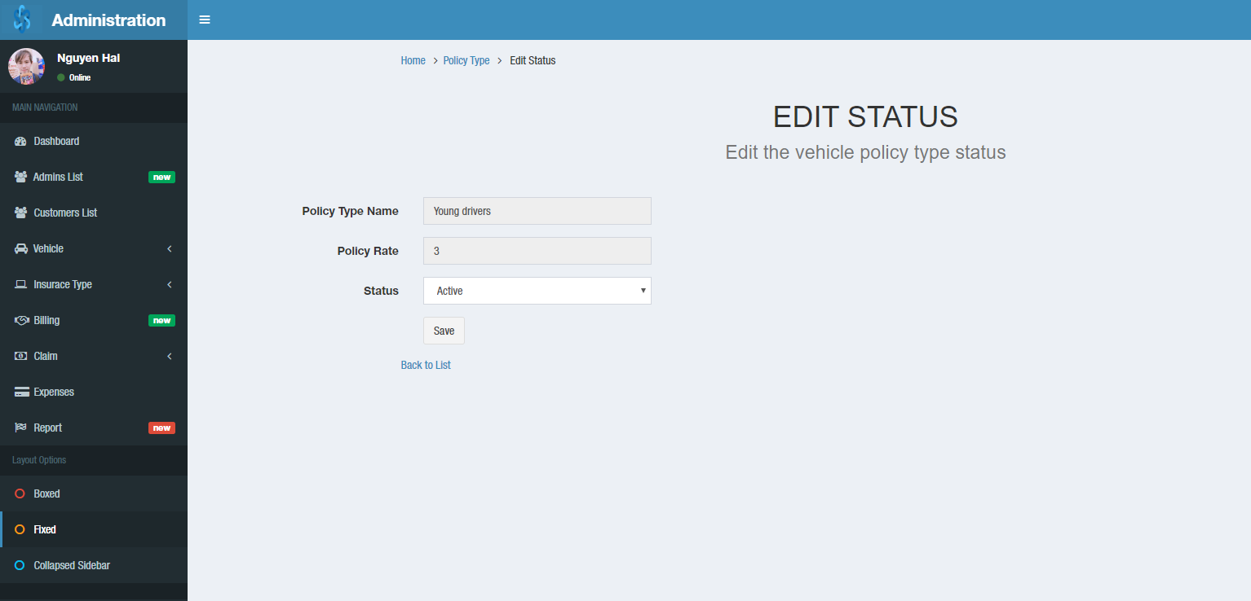

## Admin – Insurance Type – Addition service (Add prove)

Feature:

* Create new
* Edit
* Detail

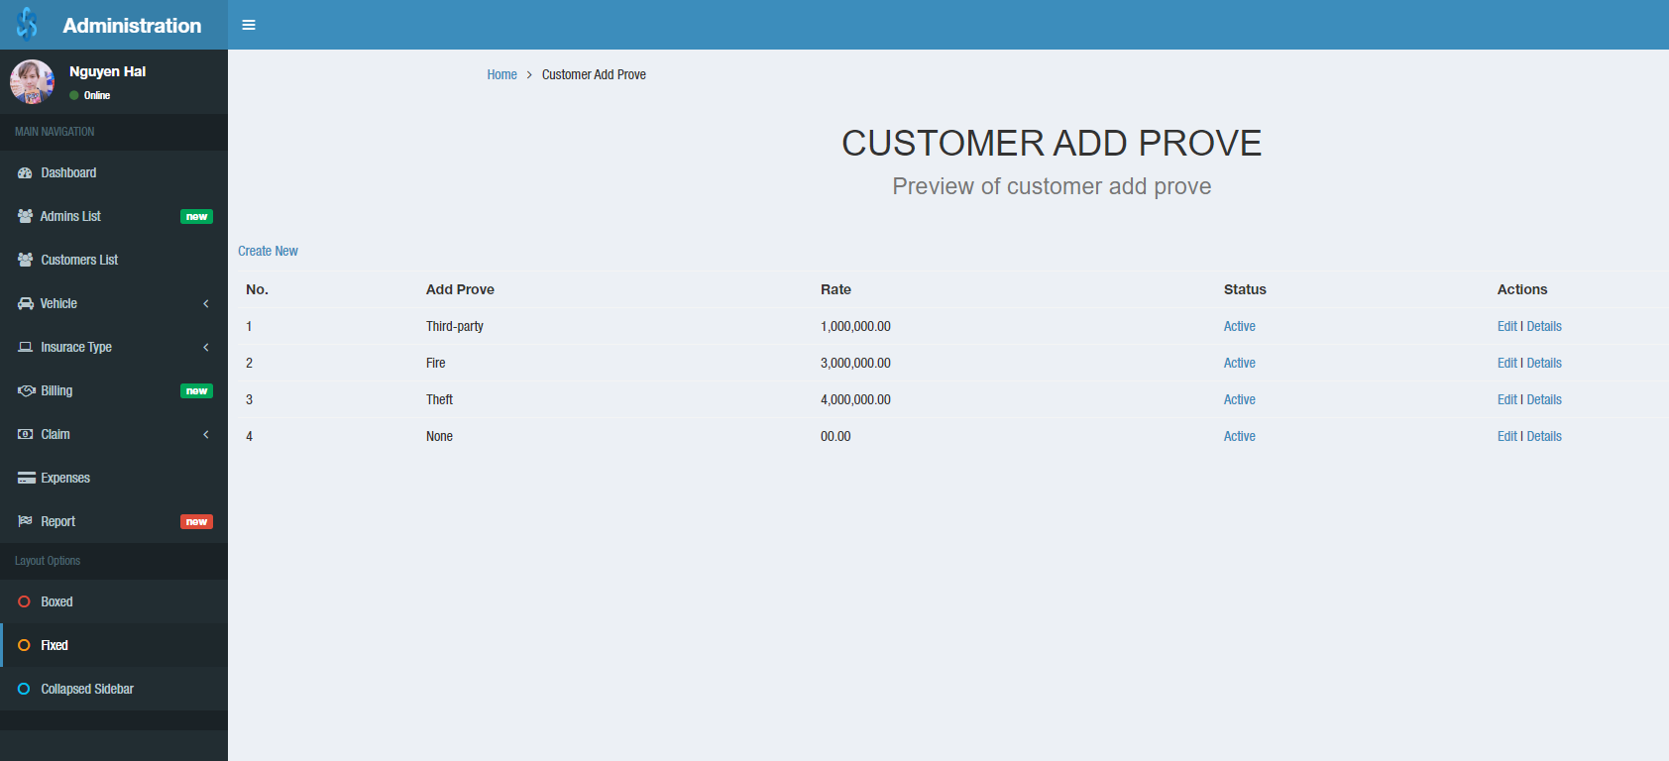

### Edit customer add prove

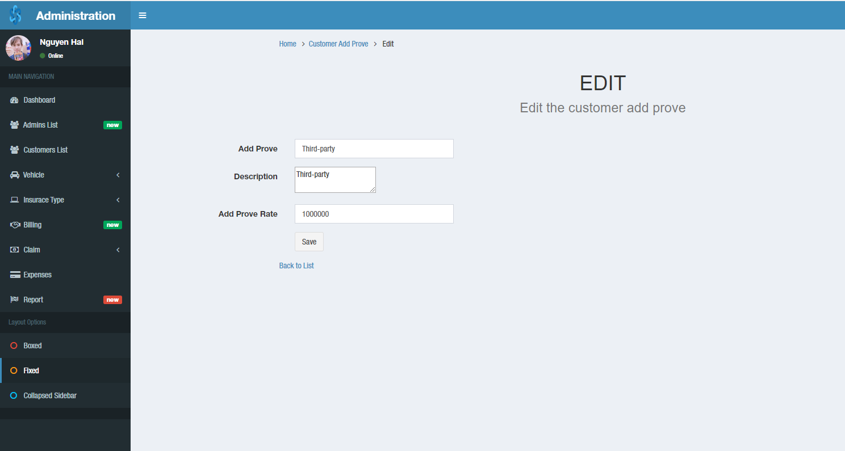

### Customer add prove details

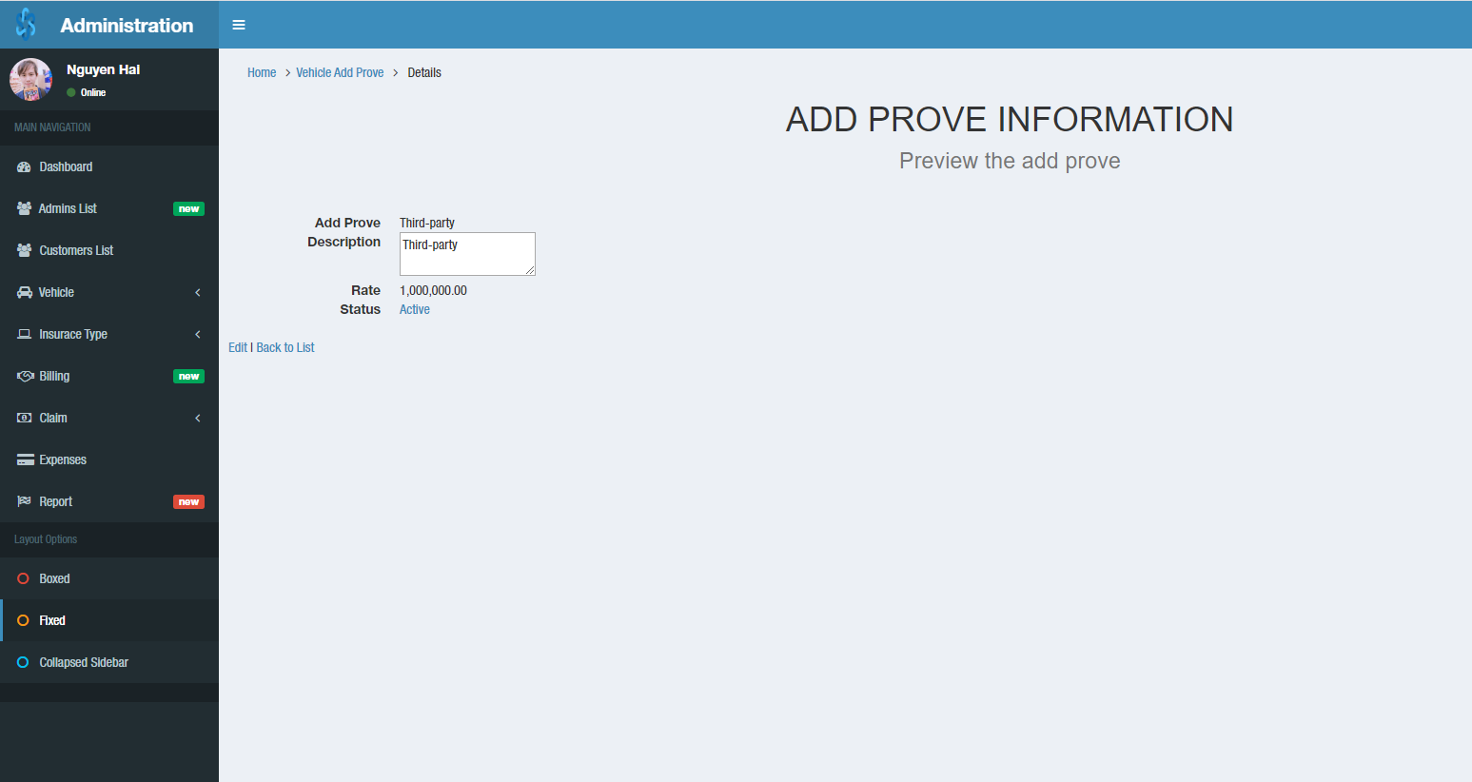

### Add prove status

Feature:

* Active / Archive additional service (add prove) status

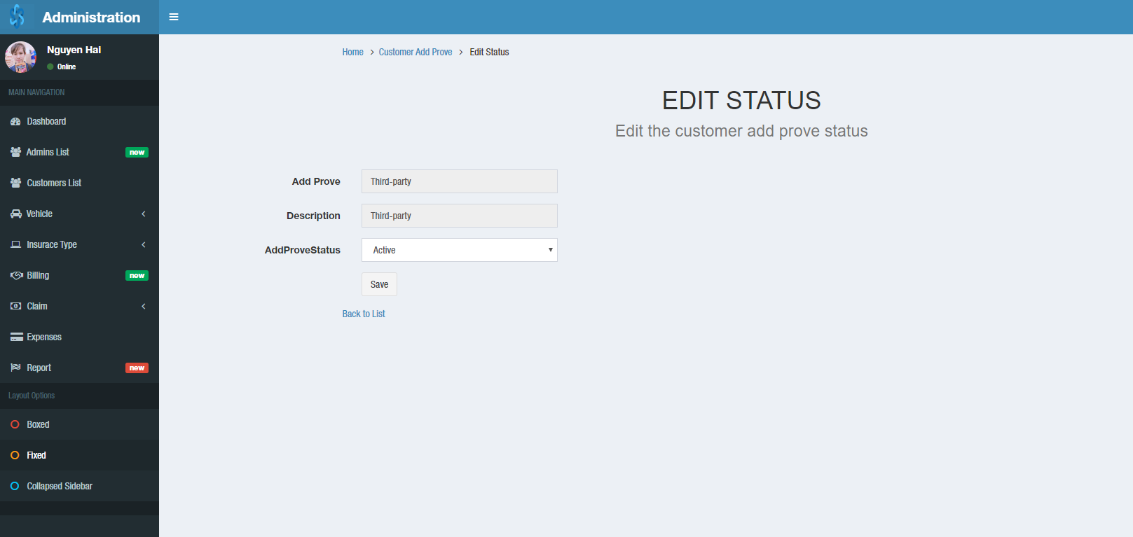

## Admin – Billing

Feature:

* Search by vehicle name
* Show the row number on a page
* Page1, 2, 3, …
* Detail

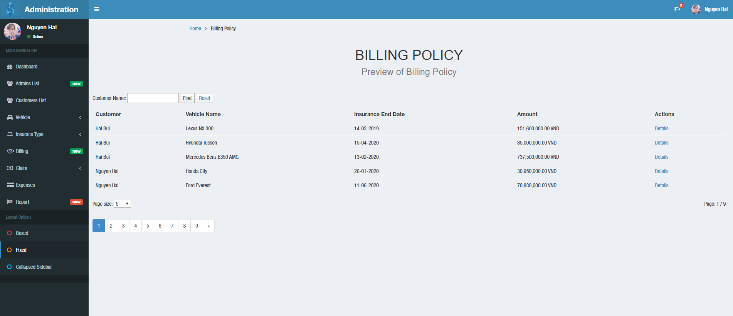

### Billing policy details

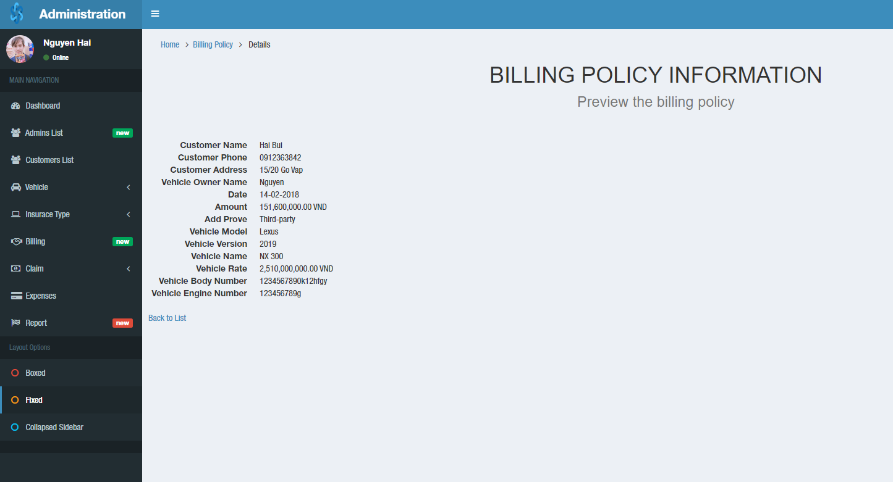

## Admin – Claim – Process

When the cusomer claim payment, the notification will show alarm (in here: ). You can see to manage and control claim from customer.

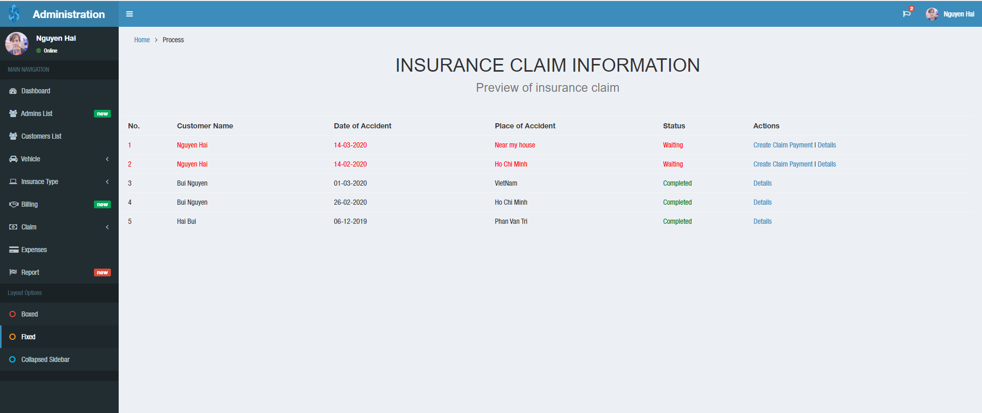

### Create claim payment

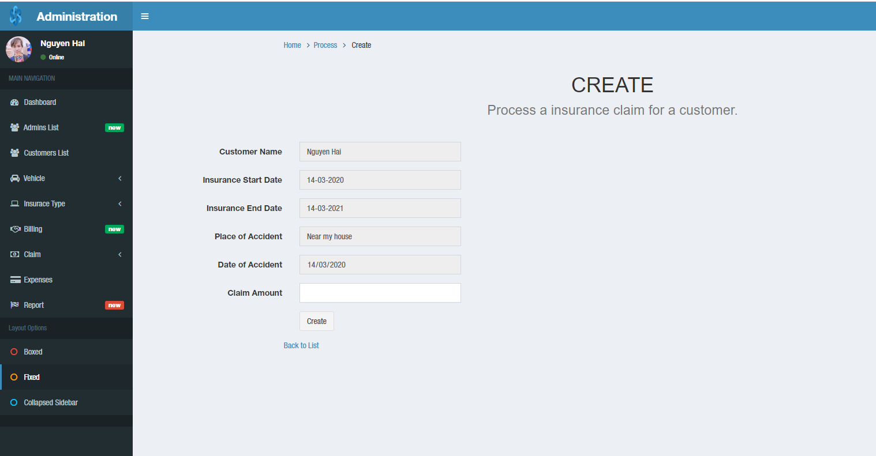

### Insurance claim details

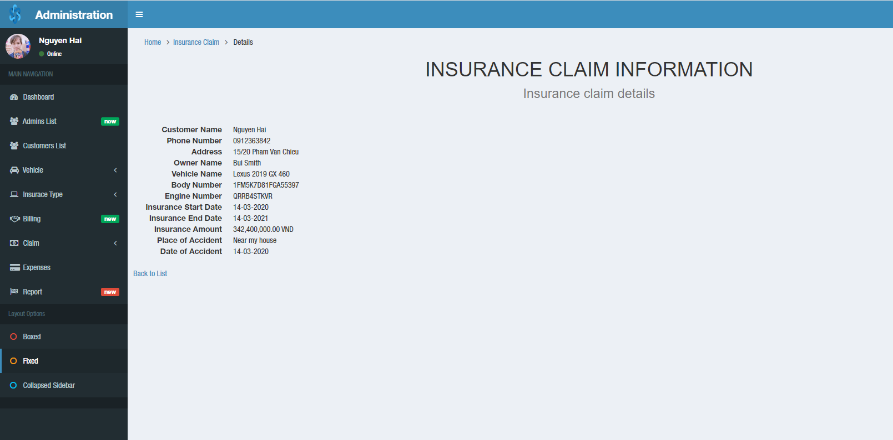

## Admin – Claim – Success

Feature:

* Search by vehicle name
* Show the row number on a page
* Page1, 2, 3, …
* Edit | Detail

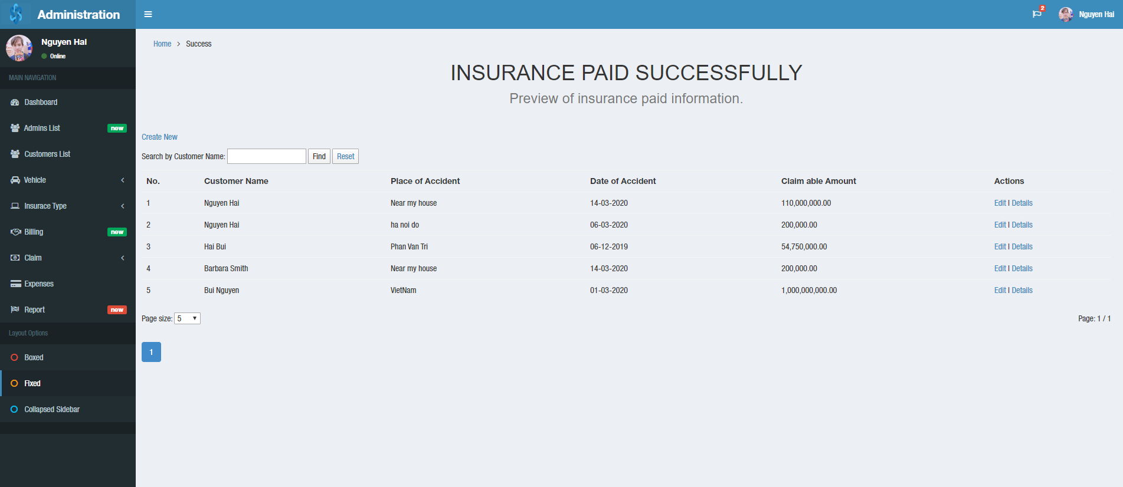

### Create new claim payment

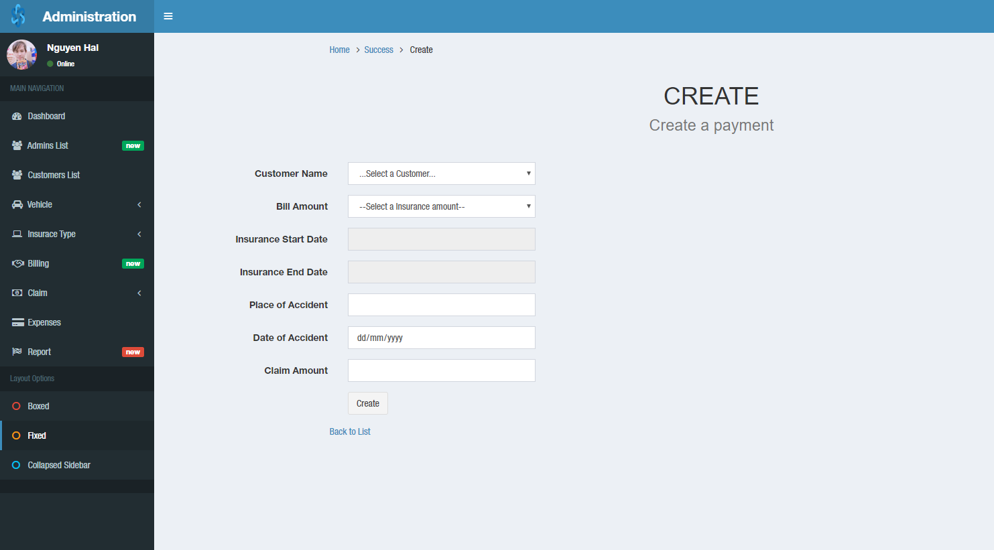

### Edit claim payment

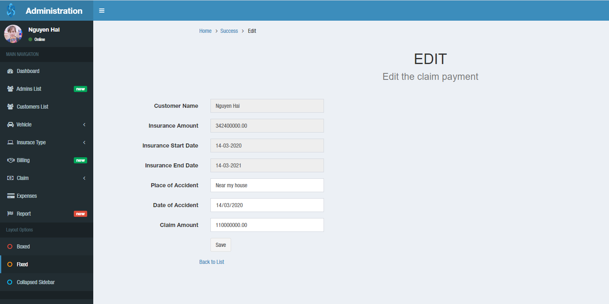

### Claim payment details

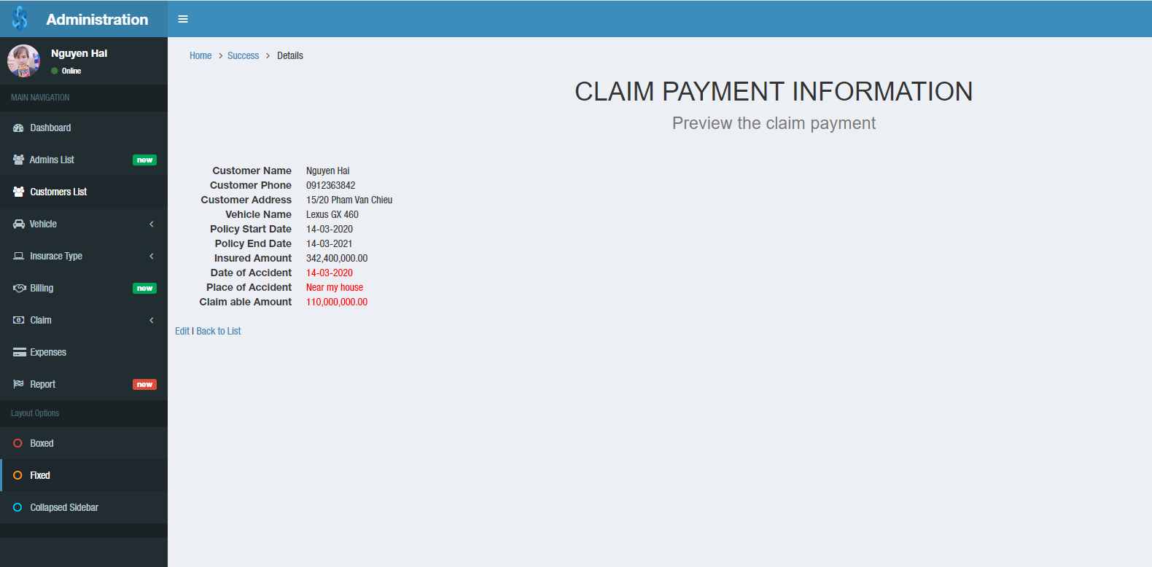

## Admin – Expenses

Feature:

* Create new
* Edit

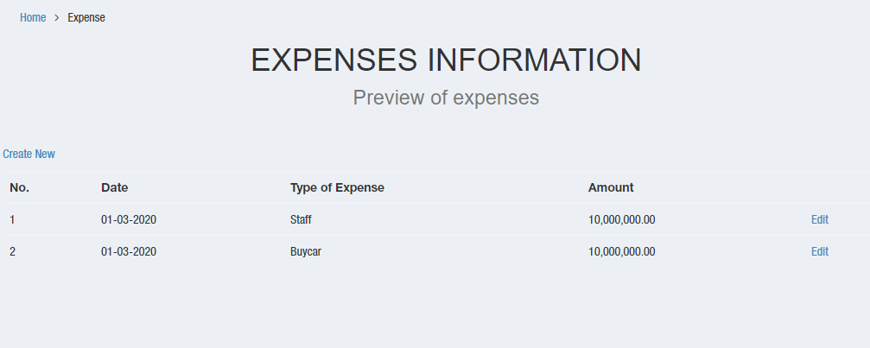

### Create new expenses

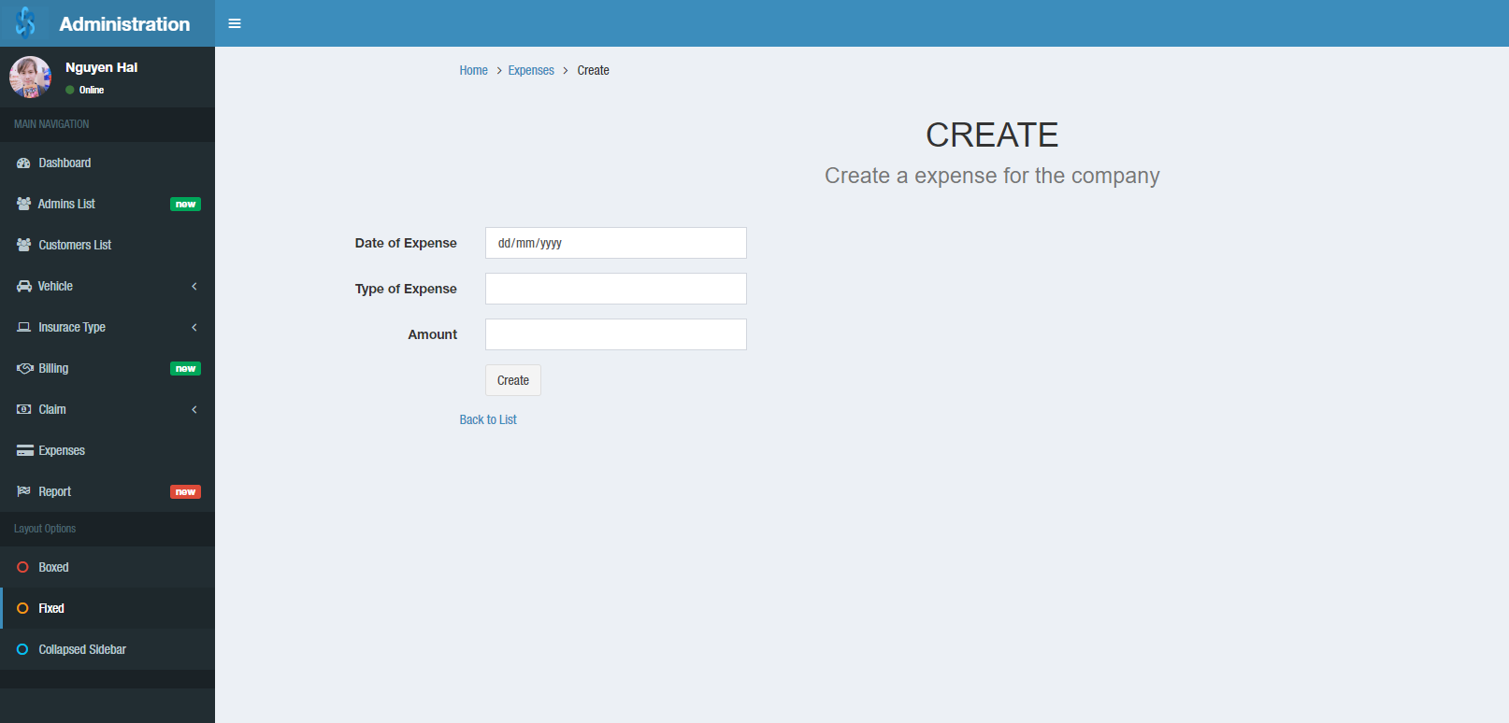

### Edit expenses company

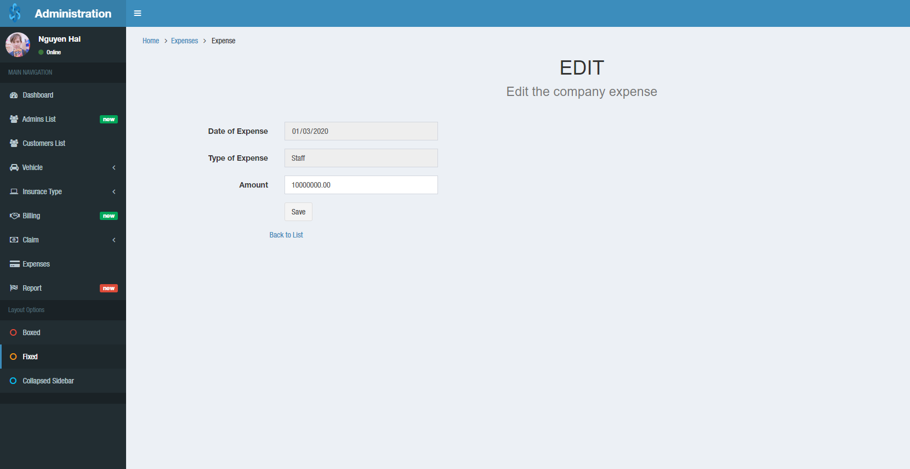

## Admin – Report

Feature:

* Customers report
* Claims report
* Billings report
* Expenses report
* Policies lapsed report

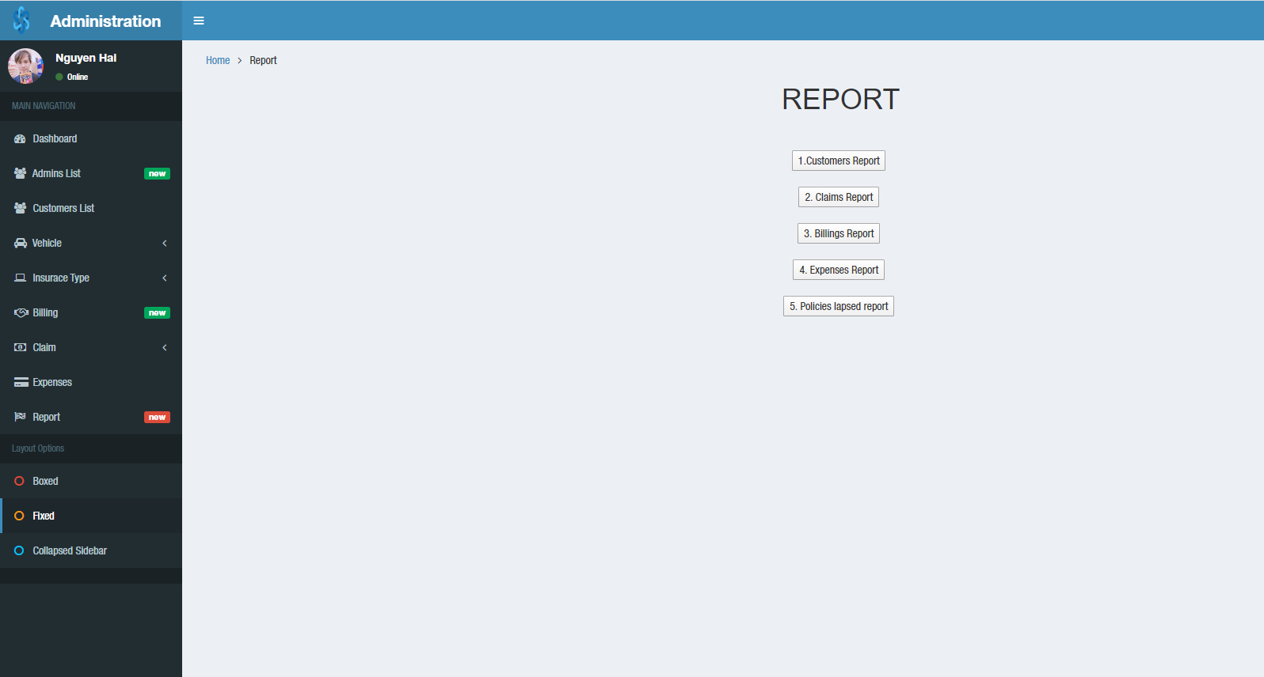

### Customers report

Feature:

* View report
* Print to PDF
* Export to…

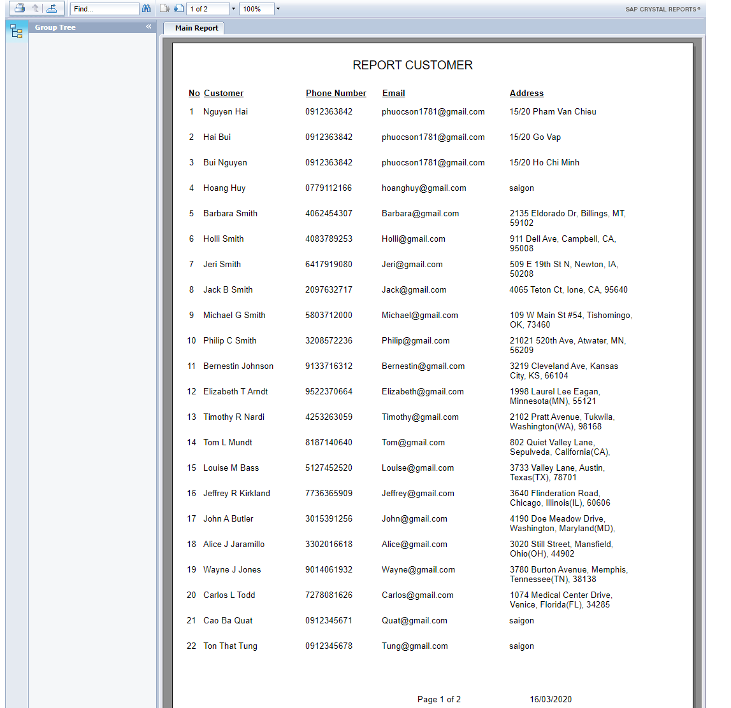

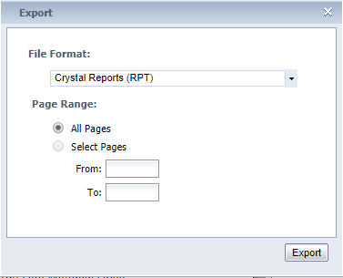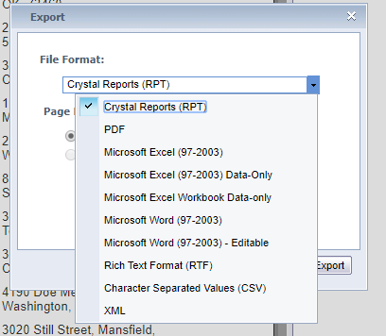

### Claims report

Feature:

* View report
* Print to PDF
* Export to…
* Total

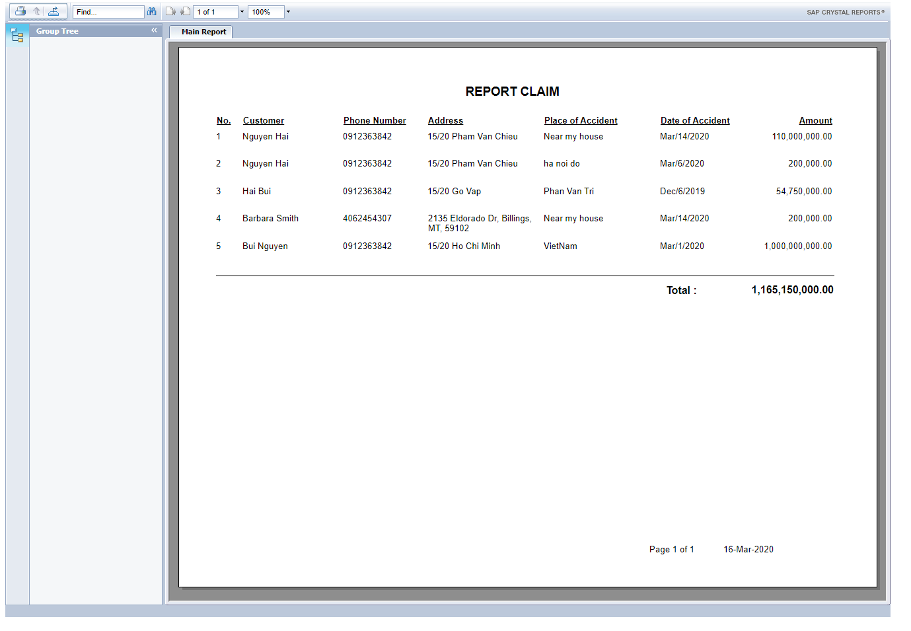

### Billings report

Feature:

* View report
* Print to PDF
* Export to…
* Total

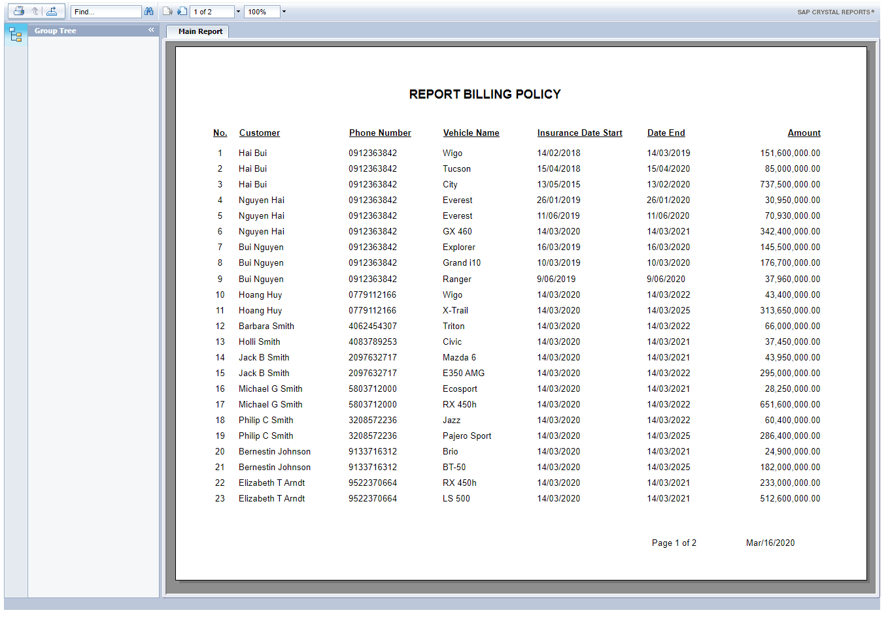

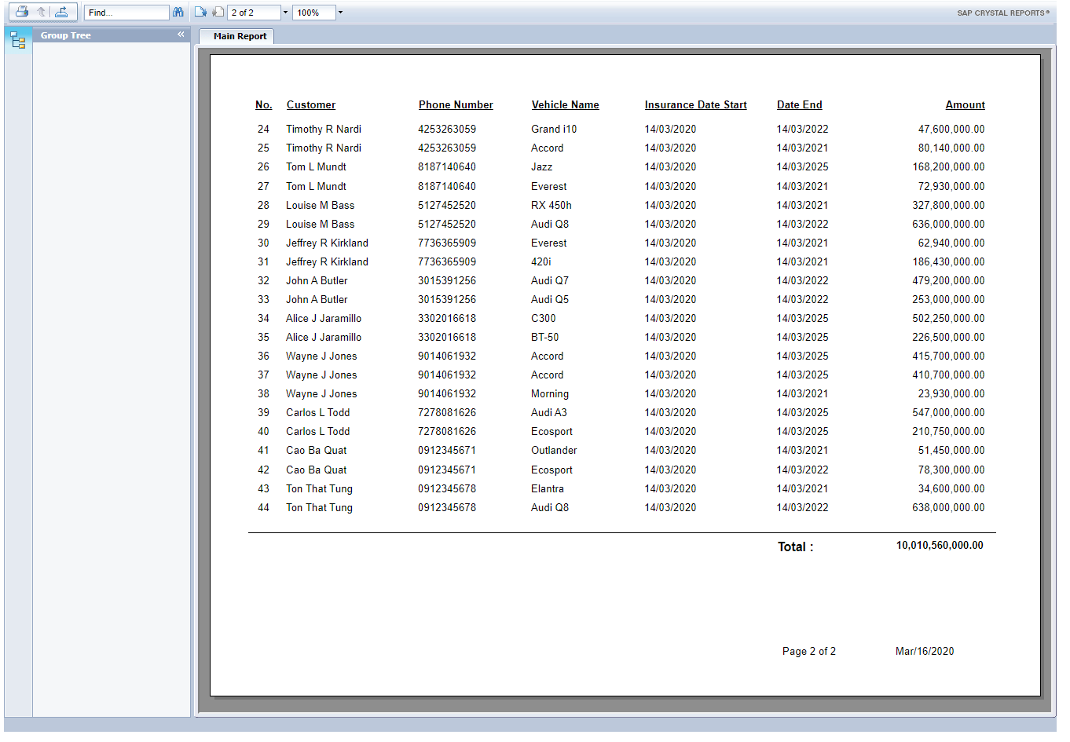

### Expenses report

Feature:

* View report
* Print to PDF
* Export to…
* Total

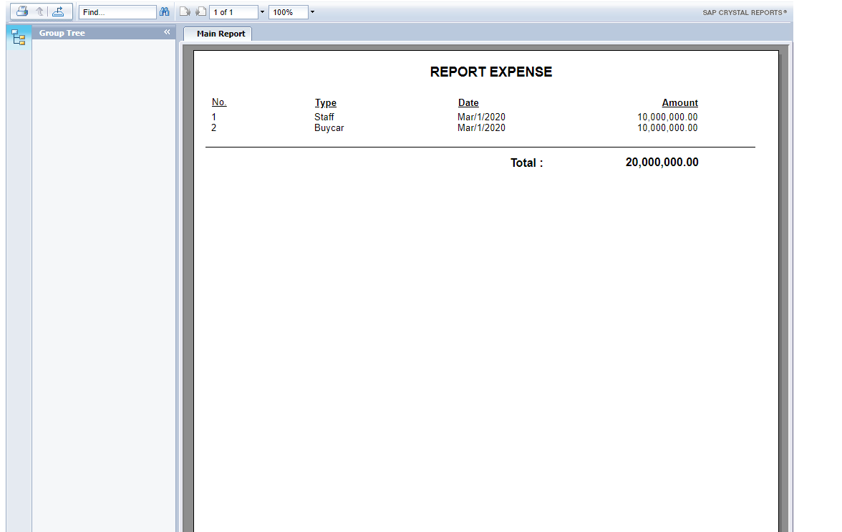

### Policies lapsed report

The policies lapsed will show 3 types:

* Expired
* 1 month left
* 3 months left

Feature:

* View report
* Print to PDF
* Export to…
* Total

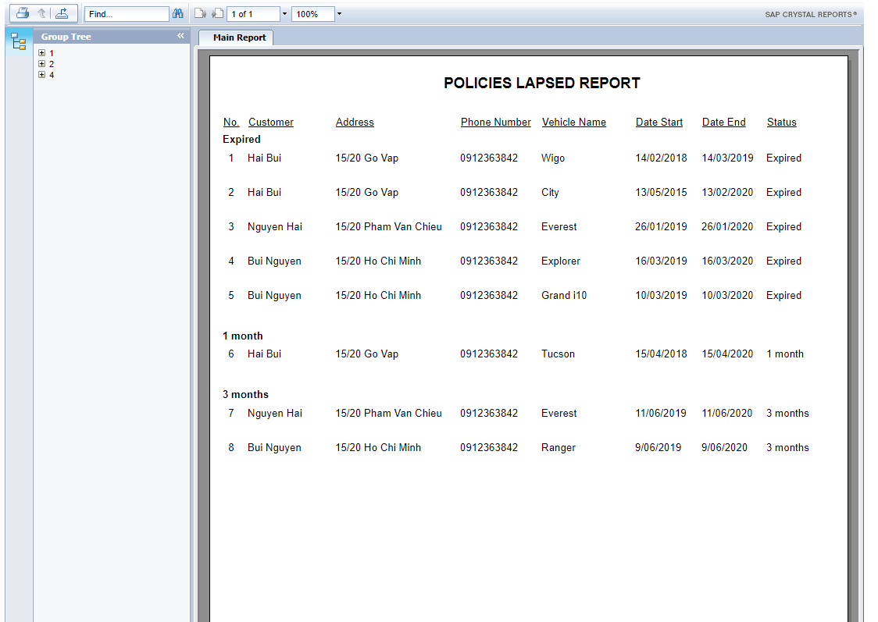

# TASK SHEET

|  |  |  |  |  |  |  |  |
| --- | --- | --- | --- | --- | --- | --- | --- |
| **Project Ref. No.: eProject / Vehicle Insurance Management** | | **Project Title:** | **Activity Plan Prepared By:** | **Date of Preparation of Activity Plan:** | | | |
| **Sr. No.** | **Task** | **Actual Start Date** | **Actual Days** | **Assigned** | **Status** |
| 1 | Problem defintion | Vehicle Insurance Management | Nguyen Huu Tung | 13/01/2020 | 7 | Tung, Hai | Completed |
| 2 | Build database | 17/01/2020 | 5 | Tung, Hai | Completed |
| 3 | Create databse | 20/01/2020 | 2 | Tung, Hai | Completed |
| 4 | Static pages | 22/01/2020 | 6 |  | Completed |
| 4.1 | - Home page | 22/01/2020 | 2 | Thư, Huy | Completed |
| 4.2 | - About Us | 27/01/2020 | 1 | Thư, Huy | Completed |
| 4.3 | - Types of Insurance | 28/01/2020 | 1 | Thư, Huy | Completed |
| 4.4 | - Testimoials | 29/01/2020 | 1 | Thư, Huy | Completed |
| 4.5 | - Site map | 30/01/2020 | 0.5 | Thư, Huy | Completed |
| 4.6 | - Contact Us | 30/01/2020 | 0.5 | Thư, Huy | Completed |
| 5 | Customer pages | 31/01/2020 | 12 |  | Completed |
| 5.1 | - Login / Register | 31/01/2020 | 1 | Thư, Huy | Completed |
| 5.2 | - Forget password | 01/02/2020 | 1 | Thư, Huy | Completed |
| 5.3 | - Profile | 02/02/2020 | 1 | Thư, Huy | Completed |
| 5.4 | - Your vehicle | 03/02/2020 | 3 | Thư, Huy | Completed |
| 5.5 | - Billing | 06/02/2020 | 3 | Tung, Hai | Completed |
| 5.6 | - Payment | 09/03/2020 | 3 | Tung, Hai | Completed |
| 6 | Combine static page to dynamic page | 12/02/2020 | 2 | Thư, Huy | Completed |
| 7 | Combine admin template to dynamic page | 14/02/2020 | 2 | Hai | Completed |
| 7.1 | Customize layout for admin template | 16/02/2020 | 1 | Thư, Huy | Completed |
| 8 | Admin pages | 17/02/2020 | 23.5 |  | Completed |
| 8.1 | - Profile | 17/02/2020 | 1 | Thư, Huy | Completed |
| 8.2 | - Dashboard | 18/02/2020 | 2 | Tung, Hai | Completed |
| 8.3 | - Admin List | 20/02/2020 | 2 | Thư, Huy | Completed |
| 8.4 | - Customer List | 22/02/2020 | 2 | Thư, Huy | Completed |
| 8.5 | - Vehicle | 24/02/2020 | 4.5 | Tung, Hai | Completed |
| 8.5.1 | * Add data to database | 24/02/2020 | 0.5 | Thư, Huy | Completed |
| 8.5.2 | * Vehicle list | 25/02/2020 | 1 | Tung, Hai | Completed |
| 8.5.3 | * Vehicle model | 26/02/2020 | 1 | Tung, Hai | Completed |
| 8.5.4 | * Vehicle Version | 27/02/2020 | 1 | Tung, Hai | Completed |
| 8.5.5 | * Vehicle Name | 28/02/2020 | 1 | Tung, Hai | Completed |
| 8.6 | - Insurance Type | 29/02/2020 | 3 | Thư, Huy | Completed |
| 8.6.1 | * Vehicle Warranty | 03/03/2020 | 1 | Thư, Huy | Completed |
| 8.6.2 | * Vehicle Policy Type | 04/03/2020 | 1 | Thư, Huy | Completed |
| 8.6.3 | * Add Prove | 05/03/2020 | 1 | Thư, Huy | Completed |
| 8.7 | - Billing | 06/03/2020 | 2 | Tung, Hai | Completed |
| 8.8 | - Claim | 08/03/2020 | 3 | Tung, Hai | Completed |
| 8.8.1 | * Payment | 10/03/2020 | 2 | Tung, Hai | Completed |
| 8.8.2 | * Claim | 11/03/2020 | 1 | Tung, Hai | Completed |
| 8.9 | - Expenses | 12/03/2020 | 1 | Thư, Huy | Completed |
| 8.10 | - Report | 13/03/2020 | 3 |  | Completed |
| 8.10.1 | * Customers report | 13/03/2020 | 3 | Tung, Hai | Completed |
| 8.10.2 | * Claims report |  |  | 13/03/2020 | 3 | Tung, Hai | Completed |
| 8.10.3 | * Billings report |  |  | 13/03/2020 | 3 | Tung, Hai | Completed |
| 8.10.4 | * Expenses report |  |  | 13/03/2020 | 3 | Tung, Hai | Completed |
| 8.10.5 | * Policies lapsed report |  |  | 13/03/2020 | 3 | Tung, Hai | Completed |
| 9 | Test code, design, field |  |  | 14/02/2020 | All times | All teams | Completed |
| 10 | Test validation |  |  | 20/02/2020 | All times | All teams | Completed |
| 11 | Write documents |  |  | 15/02/2020 | Base on schedule | Tung | Completed |

|  |  |
| --- | --- |
| **Date:** | |
| Signature of Instructor:  **Hoang Duc Quang** | Signature of team leader:  **Nguyen Huu Tung** |

# UNIT TESTING CHECK LIST

|  |  |  |  |
| --- | --- | --- | --- |
| **No.** | **Field** | **Validation** | **Show error** |
| 1 | BodyNo | Duplicate data | "BodyNo" already exists |
|  |  | Required | The BodyNo field is required. |
|  |  | {17-17} | BodyNo must be only 17 char |
|  |  | [A-Za-z0-9] | Please enter a valid bodyno |
| 2 | EngineNo | Duplicate data | "EngineNo" already exists |
|  |  | Required | The EngineNo field is required. |
|  |  | {10-10} | EngineNo must be only 10 char |
|  |  | [A-Za-z0-9] | Please enter a valid EngineNo |
| 3 | Username | Unique | Available !. you can take it. |
|  |  | immediate double Value | That name is taken.Try Another. |
|  |  | Required | The Admin User field is required. |
|  |  | [A-Za-z0-9] | Please enter a valid User |
|  |  | {3-18} | The field Admin User must be a string with a minimum length of 3 and a maximum length of 18. |
| 4 | Password | Required |  |
|  |  | (?=.*[A-Za-z])(?=.*[0-9])[A-Za-z0-9] | Passwords must have alphabet and number |
|  |  | {5-45} | Must be a string with a minimum length of 5 and a maximum length of 45. |
| 5 | File Image | Auto direct load image when select image |  |
| 6 | Admin status | Cannot access if login with "Staff" permission | You might not have permission to use this page |
| 7 | Claim Amount | Claim amount must be smaller Vehicle Rate | The amount is not valid. Claim payment must be smaller vehicle rate |
| 8 | Date of Accident | Have to greater than Insurace Start Date | Date of Accident is greater than Insurance start date! |
|  |  | Have to smaller than Insurance end date | Date of Accident is smaller than Insurance end date! |
|  |  | Have to smaller than date now | Date of Accident is smaller than date now! |
| 9 | Bill Amount | Bill Amount must have into between Insurace Start Date and Insurace EndDate |  |
| 10 | Name | Required |  |
|  |  | ^[A-Z a-z]+$ | Please enter a valid Name |
|  |  | {2-45} | The field Admin Name must be a string with a minimum length of 2 and a maximum length of 45. |
| 11 | Phone | Required | The Admin Phone field is required. |
|  |  | {10-10} | The phone numbers have only 10 numbers |
|  |  | [0-9] | Please enter a valid phone number |
| 12 | Email | Required | The Admin Email field is required. |
|  |  | {0-45} |  |
|  |  | [A-Za-z0-9._%+-]+@[A-Za-z0-9.-]+\.[A-Za-z]{2,4} | Please enter a valid email address |
| 13 | Vehicle Model | Required | The Vehicle Model field is required. |
|  |  | [A-Za-z0-9] | Please enter a valid Model |
|  |  | {3-45} | The field Vehicle Model must be a string with a minimum length of 3 and a maximum length of 45. |
| 14 | Vehicle Version | Required | The Vehicle Version field is required. |
|  |  | [0-9] | The field Vehicle Version must be a number. |
| 15 | Vehicle Name | Required | The Vehicle Name field is required. |
|  |  | [A-Za-z0-9 ] | Please enter a valid Vehicle Name |
|  |  | [3-45] | must be a string with a minimum length of 3 and a maximum length of 45. |
| 16 | Vehicle Rate | Required | The Vehicle Rate field is required. |
|  |  | (10000000, 1000000000000) | Please enter a value greater than or equal to 10000000. |
| 17 | Warranty Type | (1, 10) | The field Warranty Type must be between 1 and 10. |
| 18 | Policy Type Name | Required | The Policy Type Name field is required. |
|  |  | [3-45] | The field Policy Type Name must be a string with a minimum length of 3 and a maximum length of 45. |
|  |  | [A-Za-z0-9 ] | Please enter a valid Name |
| 19 | Description | Required | The Description field is required. |
|  |  | [3-290] | The field Description must be a string with a minimum length of 3 and a maximum length of 290. |
| 20 | Policy Rate | [5-20] | The field Policy Rate must be between 5 and 20. |
| 21 | Add Prove | Required | The Add Prove field is required. |
|  |  | [3-45] | The field Add Prove must be a string with a minimum length of 3 and a maximum length of 45. |
|  |  | [A-Za-z0-9 ./\^-] | Please enter a valid Name |
| 22 | Add Prove Rate | (0, 10000000) | The field Add Prove Rate must be between 0 and 10000000. |
| 23 | Place of Accident | Required | The Place of Accident field is required. |
|  |  | [5-18] | The field Place of Accident must be a string with a minimum length of 5 and a maximum length of 18. |
|  |  | [A-Za-z 0-9./\^] | Please enter a valid place of accident |
| 24 | Date of Accident | Required | The Date of Accident field is required. |
| 25 | Claim Amount | Required | The Claim Amount field is required. |
|  |  | (100000, 10000000000) | The field Claim Amount must be between 100000 and 10000000000. |
| 26 | Amount | Required | The Amount field is required. |
|  |  | [0-9] | The field Amount must be a number. |
|  |  | (100000, 10000000000) | The field Amount must be between 100000 and 10000000000. |
| 27 | Old password | required | The Old Password field is required. |
|  |  | {5-45} | The field Old Password must be a string with a minimum length of 5 and a maximum length of 45. |
|  |  | A-Za-z0-9 | The Old Password is invalid |
| 28 | New password | required | The New Password field is required |
|  |  | {5-45} | The field New Password must be a string with a minimum length of 5 and a maximum length of 45. |
|  |  | A-Za-z0-9 | Password need alphabet and number |
| 29 | Password Confirm | required | The New Password Confirm field is required |
|  |  | {5-45} | The field New Password Confirm must be a string with a minimum length of 5 and a maximum length of 45 |
|  |  | A-Za-z0-9 | Password need alphabet and number |